# VISVESVARAYA TECHNOLOGICAL UNIVERSITY

**“JnanaSangama”, Belgaum -590014, Karnataka.**



## LAB REPORT

### on

Machine Learning (23CS6PCMAL)

#### Submitted by

**Aneesh K P(1BM22CS040)**

#### in partial fulfillment for the award of the degree of

**BACHELOR OF ENGINEERING**

***in***

## COMPUTER SCIENCE AND ENGINEERING



**B.M.S. COLLEGE OF ENGINEERING**

**(Autonomous Institution under VTU)**

## BENGALURU-560019

### Feb-2025 to June-2025

**B.M.S. College of Engineering,**

**Bull Temple Road, Bangalore 560019**

(Affiliated To Visvesvaraya Technological University, Belgaum)

**Department of Computer Science and Engineering**



##### CERTIFICATE

This is to certify that the Lab work entitled “Machine Learning (23CS6PCMAL)” carried out by **Aneesh K P(1BM22CS040),** who is a bonafide student of **B.M.S. College of Engineering.** It is in partial fulfillment for the award of **Bachelor of Engineering in Computer Science and Engineering** of the Visvesvaraya Technological University, Belgaum. The Lab report has been approved as it satisfies the academic requirements in respect of a Machine Learning (23CS6PCMAL) work prescribed for the said degree.

**Dr. Kavitha Sooda** Professor & HOD

Department of CSE, BMSCE

**Lab Faculty Incharge**

Name: **Prof. Saritha A N**

Assistant Professor Department of CSE, BMSCE

# Index

|  |  |  |  |
| --- | --- | --- | --- |
| **Sl. No.** | **Date** | **Experiment Title** | **Page No.** |
| 1 | 4-3-2025 | Write a python program to import and export data using Pandas library functions | 1 |
| 2 | 11-3-2025 | Demonstrate various data pre-processing techniques for a given dataset | 14 |
| 3 | 18-3-2025 | Use an appropriate data set for building the decision tree (ID3) and apply this knowledge to classify a new sample. | 28 |
| 4 | 1-4-2025 | Implement Linear and Multi-Linear Regression  algorithm using appropriate dataset | 31 |
| 5 | 8-4-2025 | Build Logistic Regression Model for a given  Dataset | 33 |
| 6 | 15-4-2025 | Build KNN Classification model for a given dataset | 42 |
| 7 | 15-4-2025 | Build Support vector machine model for a given dataset | 45 |
| 8 | 22-4-2025 | Implement Random forest ensemble method on a given dataset | 48 |
| 9 | 22-4-2025 | Implement Boosting ensemble method on a given dataset | 50 |
| 10 | 29-4-2025 | Build k-Means algorithm to cluster a set of data stored in a .CSV file | 52 |
| 11 | 29-4-2025 | Implement Dimensionality reduction using Principal Component Analysis (PCA) method | 55 |

**Github Link:**

<https://github.com/aneeshkp55/ML-Lab>

##### Program 1

Write a python program to import and export data using Pandas library functions

**Screenshots**

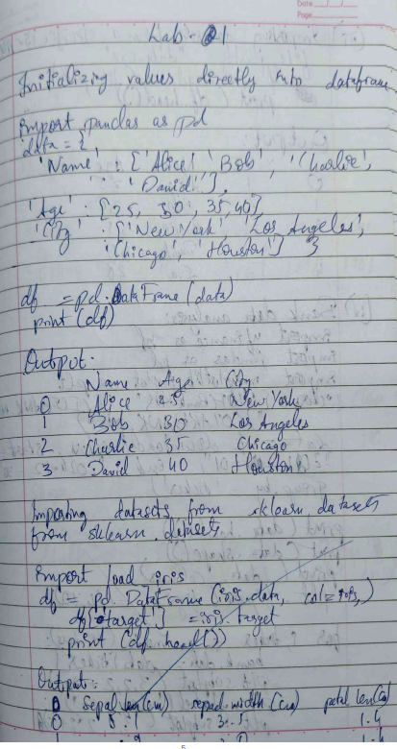

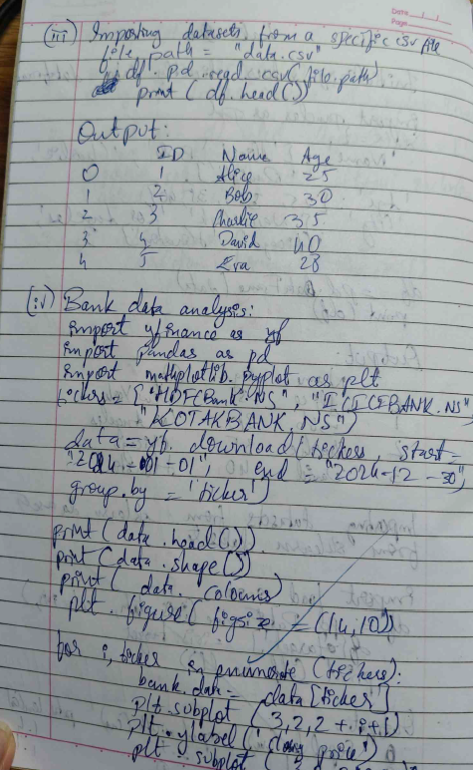

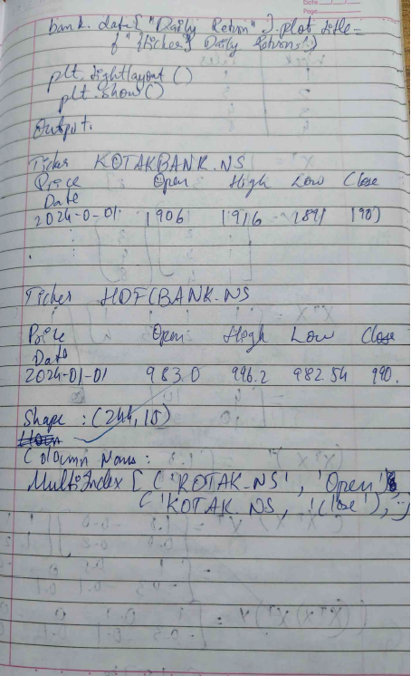

**Code:**

import pandas as pd

# Create a DataFrame directly from a dictionary

data = {

'Name': ['Alice', 'Bob', 'Charlie', 'David'],

'Age': [25, 30, 35, 40],

'City': ['New York', 'Los Angeles', 'Chicago', 'Houston']

}

df = pd.DataFrame(data)

print("Sample data:")

print(df.head())

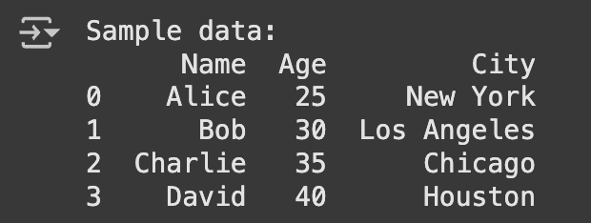

from sklearn.datasets import load_iris

iris = load_iris()

df = pd.DataFrame(iris.data, columns=iris.feature_names)

df['target'] = iris.target

print("Sample data:")

print(df.head())

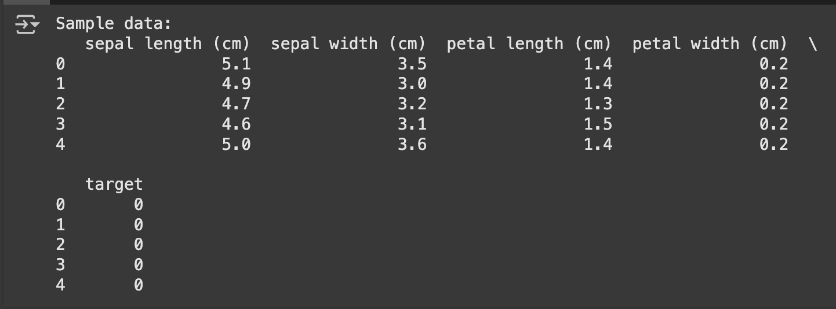

# Load data from a CSV file (replace 'data.csv' with your file path)

file_path = '/content/industry.csv'

# Ensure the file exists in the same directory

df = pd.read_csv(file_path)

print("Sample data:")

print(df.head())

print("\n")

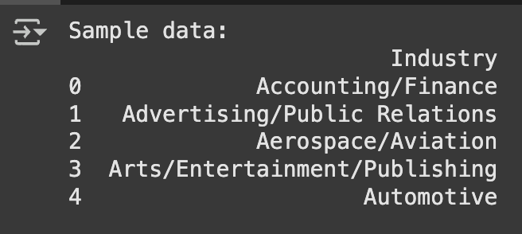

import pandas as pd

# Reading data from a CSV file

data = {

'Name': ['Alice', 'Bob', 'Charlie', 'David', 'Evangline'],

'USN': ['1BM22CS025', '1BM22CS030', '1BM22CS035', '1BM22CS040', '1BM22CS045'],

'Marks': [25, 30, 35, 40, 45]

}

df = pd.DataFrame(data)

print("Sample data:")

print(df.head())

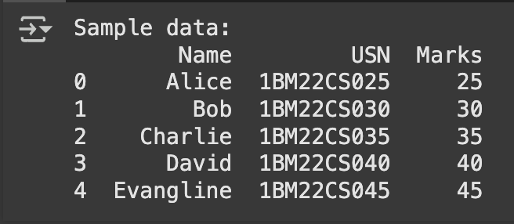

from sklearn.datasets import load_diabetes

dia = load_diabetes()

df = pd.DataFrame(dia.data, columns=dia.feature_names)

df['target'] = dia.target

print("Sample data:")

print(df.head())

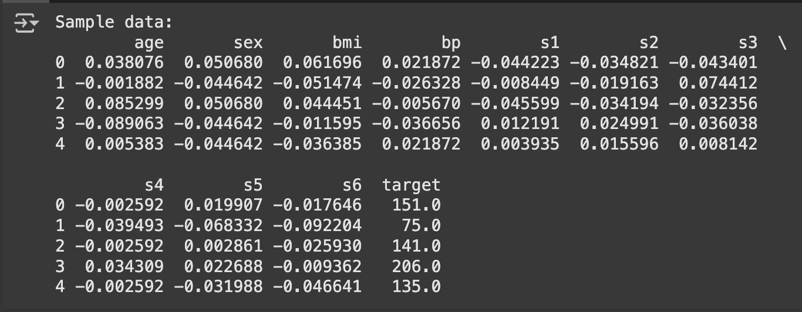

# Load data from a CSV file (replace 'data.csv' with your file path)

file_path = '/content/sample_data/california_housing_train.csv' # Ensure the file exists in the same directory

df = pd.read_csv(file_path)

print("Sample data:")

print(df.head())

print("\n")

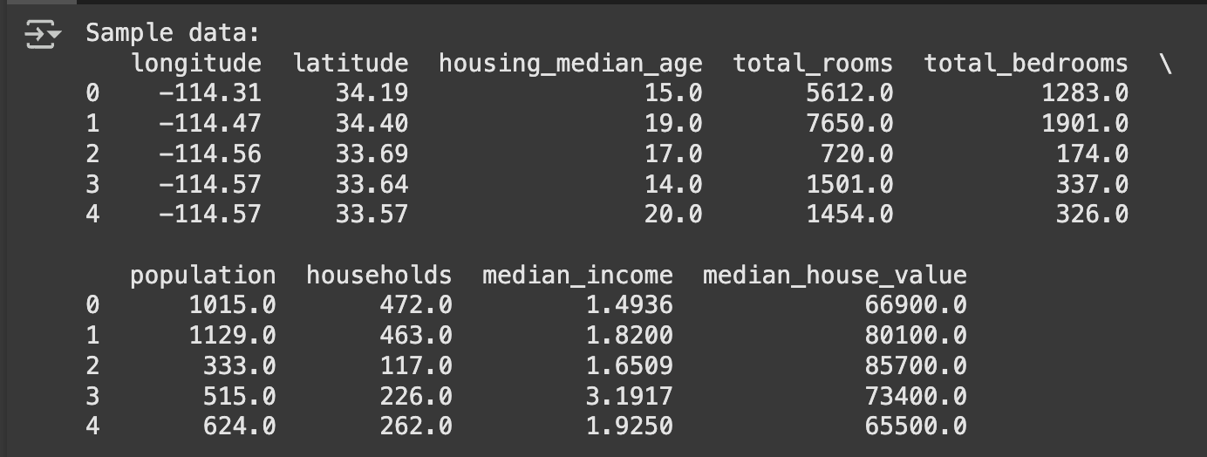

# Load data from a CSV file (replace 'data.csv' with your file path)

# downloading and loading

file_path = '/content/Dataset of Diabetes .csv' # Ensure the file exists in the same directory

df = pd.read_csv(file_path)

print("Sample data:")

print(df.head())

print("\n")

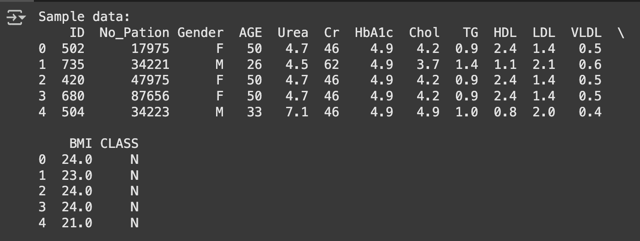

import pandas as pd

# Reading data from a CSV file

df =pd.read_csv('/content/sample_data/california_housing_test.csv')

# Displaying the first few rowsof the DataFrame

print(df.head())

# Writing the DataFrame to a CSV file

df.to_csv('output.csv',index=False)

print("Data saved tooutput.csv")

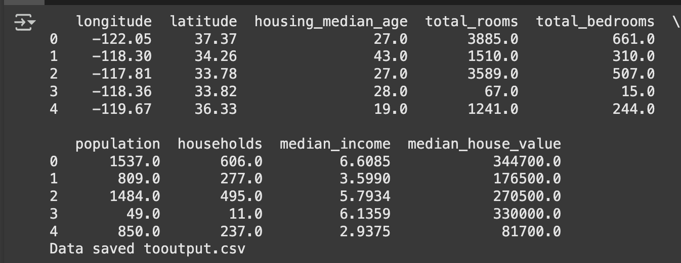

# Reading sales data from a CSV file

california_df =pd.read_csv('/content/sample_data/california_housing_test.csv')

# Displaying the first fewrows of the dataset

print("First few rows of the california_housing_test data:")

print(california_df.head())

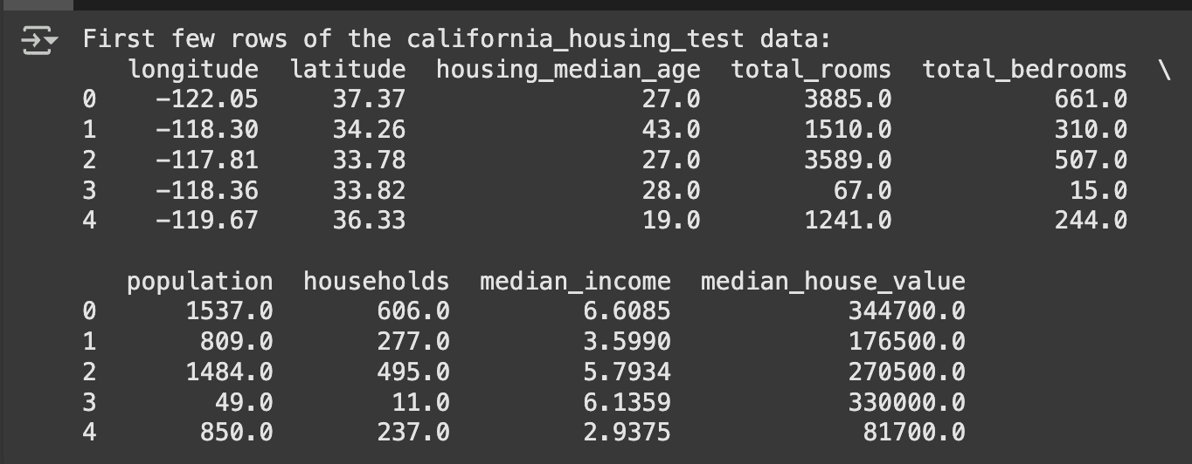

# Grouping by Region and calculating total sales

california =california_df.groupby('total_rooms')['total_bedrooms'].sum()

print("\nTotal housing by region:")

print(california)

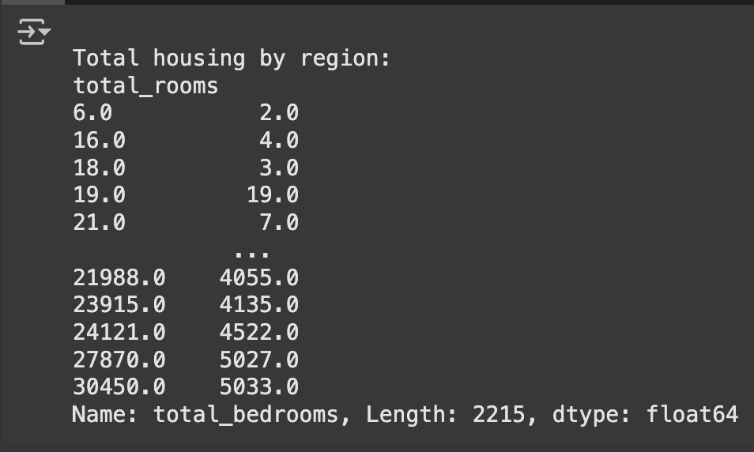

# Grouping by Product and calculating total quantity sold

best_selling_homes = california_df.groupby('housing_median_age')['households'].sum().sort_values(ascending=False)

print("\nBest-selling products by quantity:")

print(best_selling_homes)

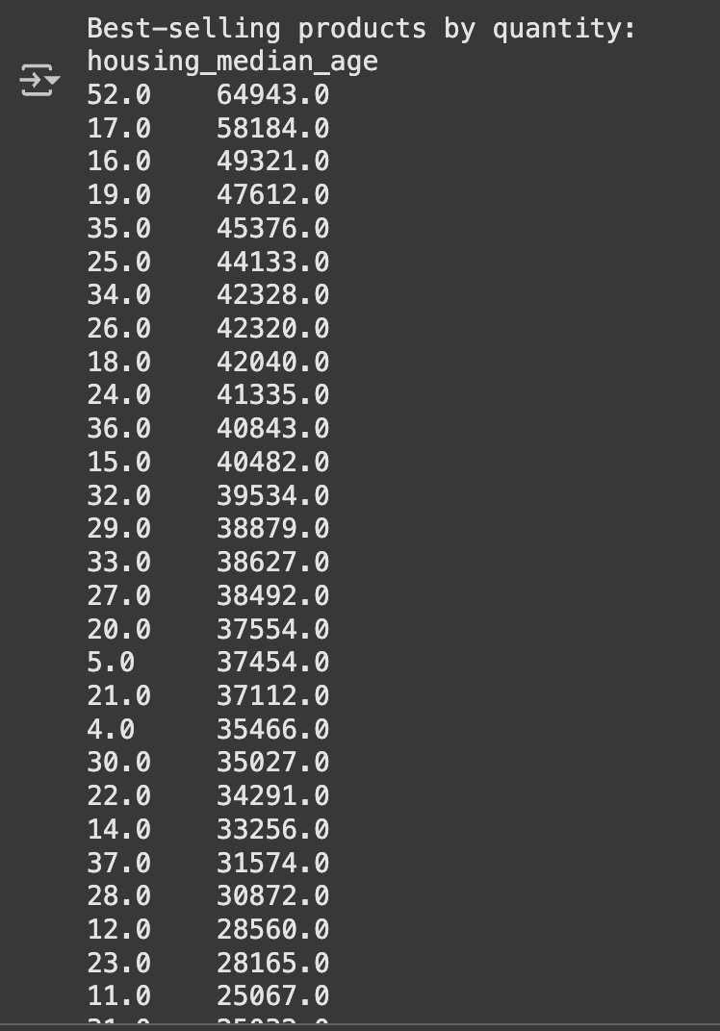

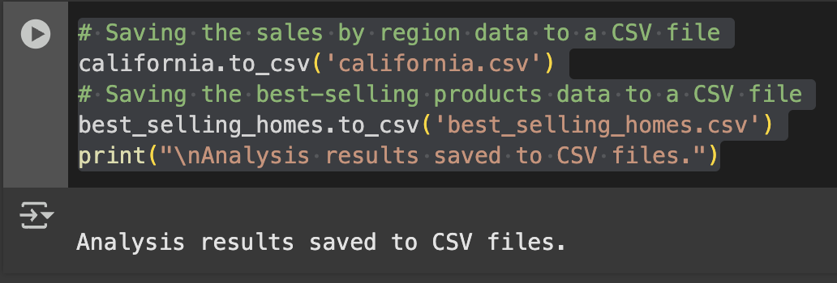

import yfinance as yf

import pandas as pd

import matplotlib.pyplot as plt

# Step 2: Downloading Stock Market Data

# Define the ticker symbols for Indian companies

# Example: Reliance Industries (RELIANCE.NS), TCS (TCS.NS), Infosys (INFY.NS)

tickers = ["RELIANCE.NS", "TCS.NS", "INFY.NS"]

# Fetch historical data for the last 1 year

data = yf.download(tickers, start="2022-10-01", end="2023-10-01",

group_by='ticker')

# Display the first 5 rows of the dataset

print("First 5 rows of the dataset:")

print(data.head())

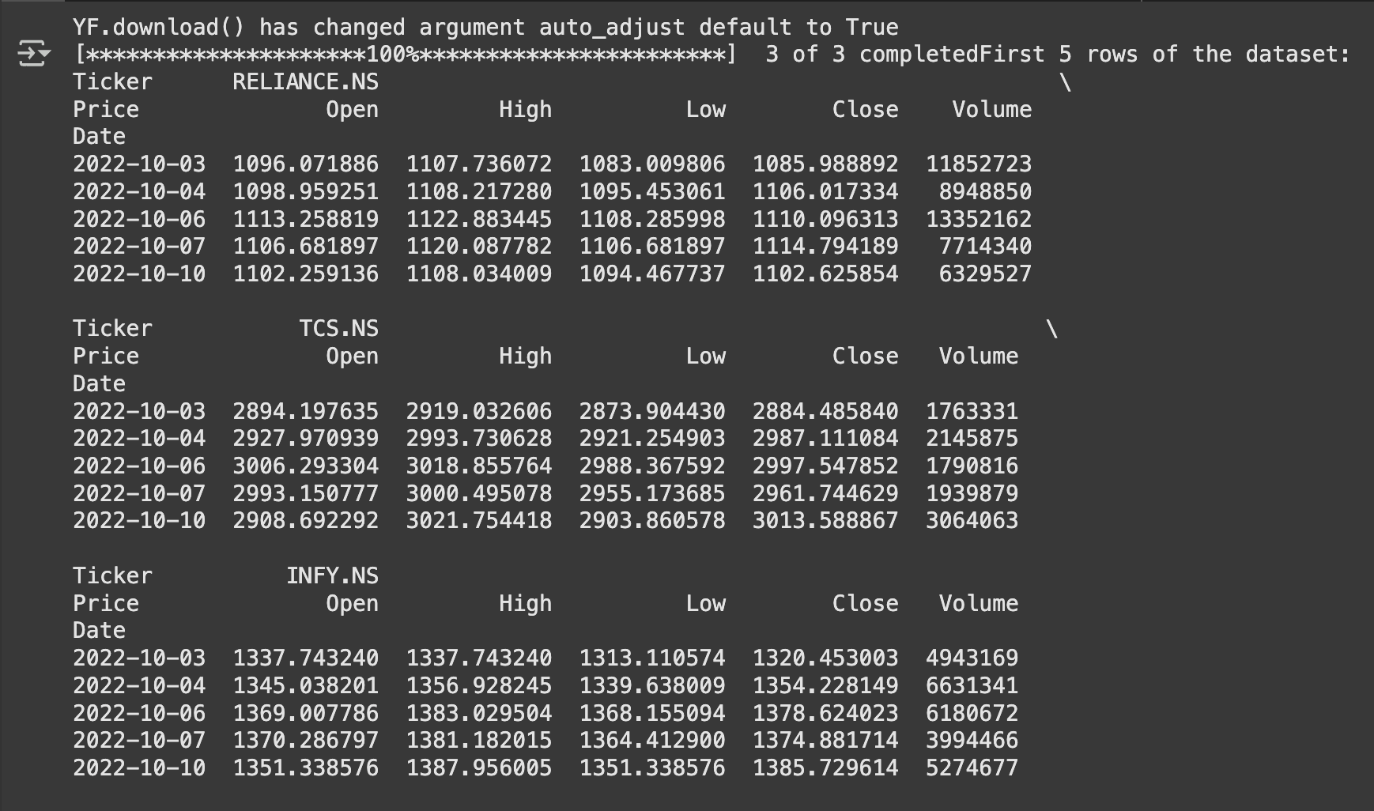

# Step 3: Basic Data Exploration

# Check the shape of the dataset

print("\nShape of the dataset:")

print(data.shape)

# Check column names

print("\nColumn names:")

print(data.columns)

# Summary statistics for a specific stock (e.g., Reliance)

reliance_data = data['RELIANCE.NS']

print("\nSummary statistics for Reliance Industries:")

print(reliance_data.describe())

# Calculate daily returns

# Create a copy of the Reliance data to avoid modifying a slice of the original dataframe

reliance_data = data['RELIANCE.NS'].copy()

# Now, apply the calculation

reliance_data['Daily Return'] = reliance_data['Close'].pct_change()

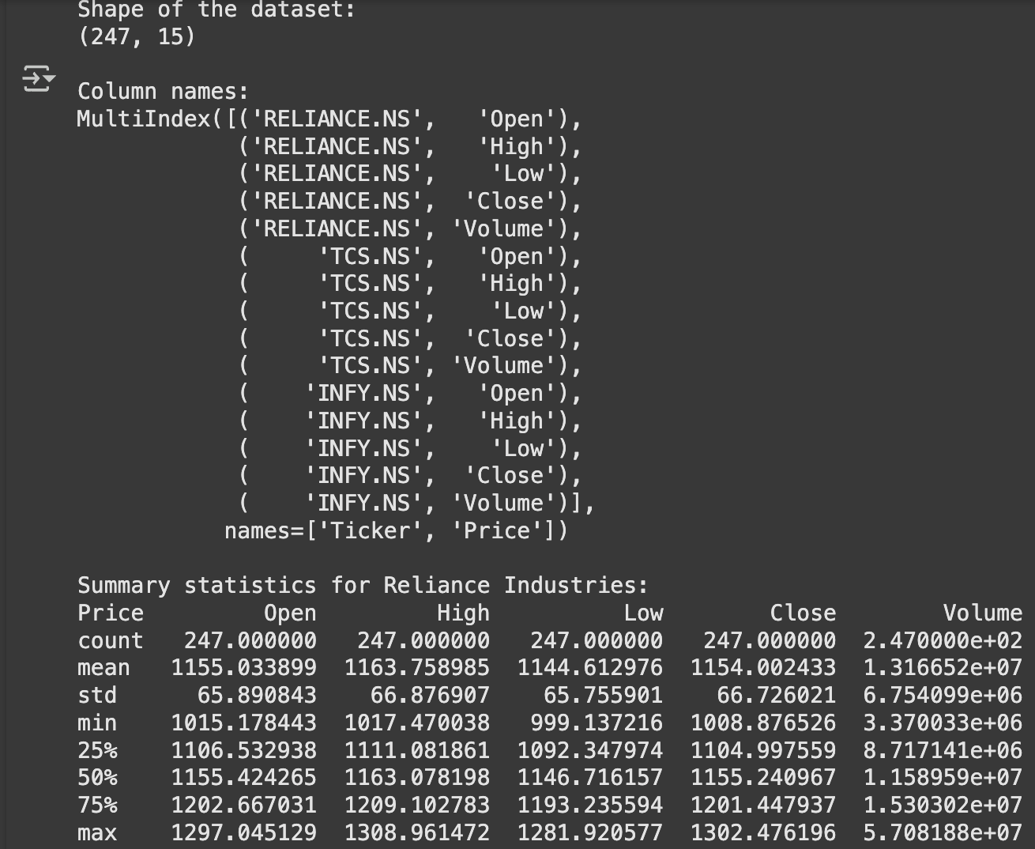

# Plot the closing price and daily returns

plt.figure(figsize=(12, 6))

plt.subplot(2, 1, 1)

reliance_data['Close'].plot(title="Reliance Industries - Closing Price")

plt.subplot(2, 1, 2)

reliance_data['Daily Return'].plot(title="Reliance Industries - Daily Returns", color='orange')

plt.tight_layout()

plt.show()

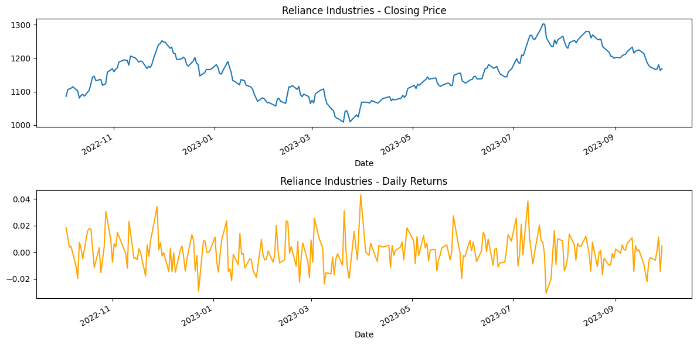

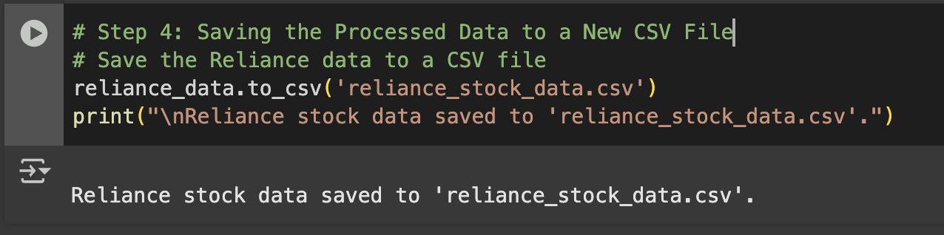

tickers = ["HDFCBANK.NS", "ICICIBANK.NS", "KOTAKBANK.NS"]

data = yf.download(tickers, start="2024-01-01", end="2024-12-30",

group_by='ticker')

# Display the first 5 rows of the dataset

print("First 5 rows of the dataset:")

print(data.head())

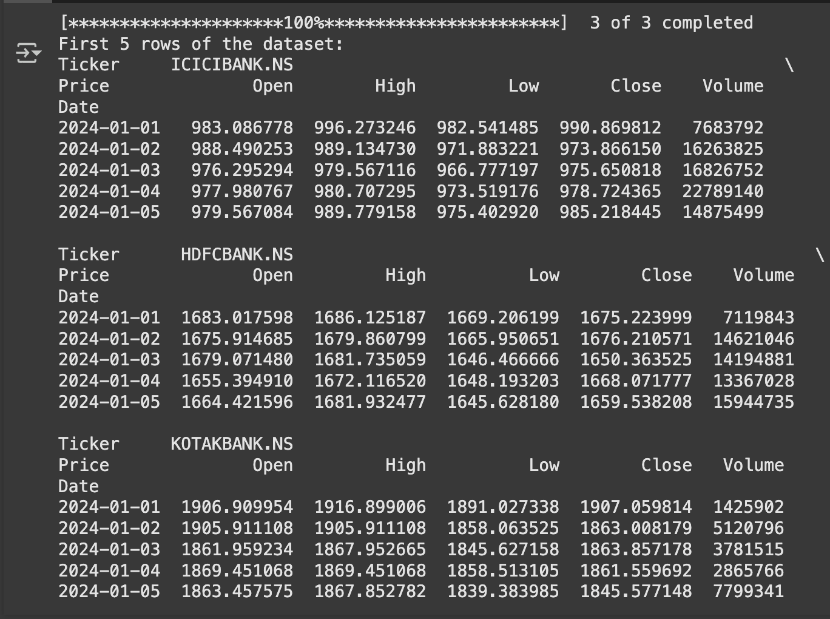

HDFC = data['HDFCBANK.NS']

print("\nSummary statistics for HDFC:")

print(HDFC.describe())

# Calculate daily returns

# Create a copy of the Reliance data to avoid modifying a slice of the original dataframe

HDFC = data['HDFCBANK.NS'].copy()

# Now, apply the calculation

HDFC['Daily Return'] = HDFC['Close'].pct_change()

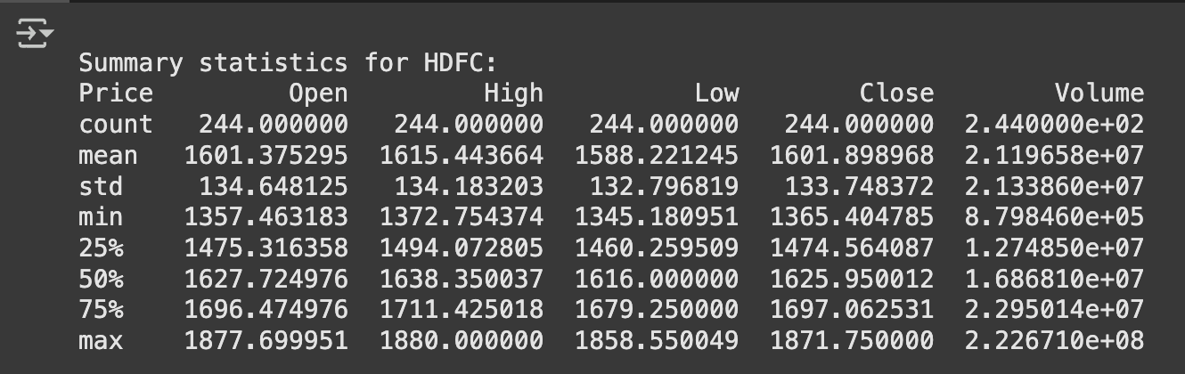

ICICI = data['ICICIBANK.NS']

print("\nSummary statistics for ICICI:")

print(ICICI.describe())

# Calculate daily returns

# Create a copy of the Reliance data to avoid modifying a slice of the original dataframe

ICICI = data['ICICIBANK.NS'].copy()

# Now, apply the calculation

ICICI['Daily Return'] = ICICI['Close'].pct_change()

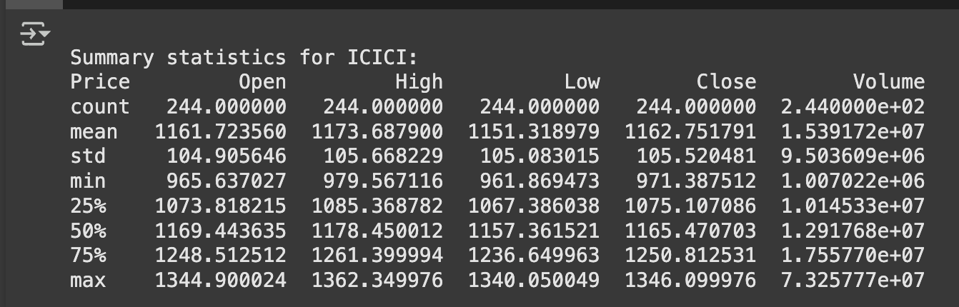

KOTAKBANK = data['KOTAKBANK.NS']

print("\nSummary statistics for KOTAKBANK:")

print(KOTAKBANK.describe())

# Calculate daily returns

# Create a copy of the Reliance data to avoid modifying a slice of the original dataframe

KOTAKBANK = data['KOTAKBANK.NS'].copy()

# Now, apply the calculation

KOTAKBANK['Daily Return'] = KOTAKBANK['Close'].pct_change()

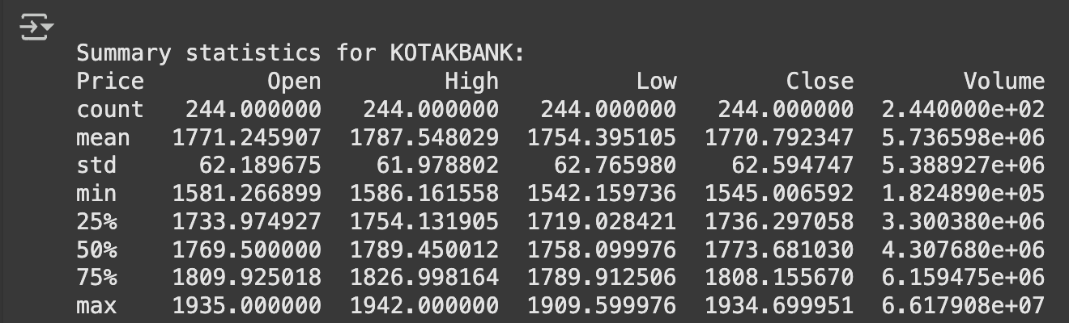

# Plot the closing price and daily returns

plt.figure(figsize=(12, 6))

plt.subplot(2, 1, 1)

HDFC['Close'].plot(title="HDFCBANK - Closing Price")

plt.subplot(2, 1, 2)

HDFC['Daily Return'].plot(title="HDFCBANK - Daily Returns", color='orange')

plt.tight_layout()

plt.show()

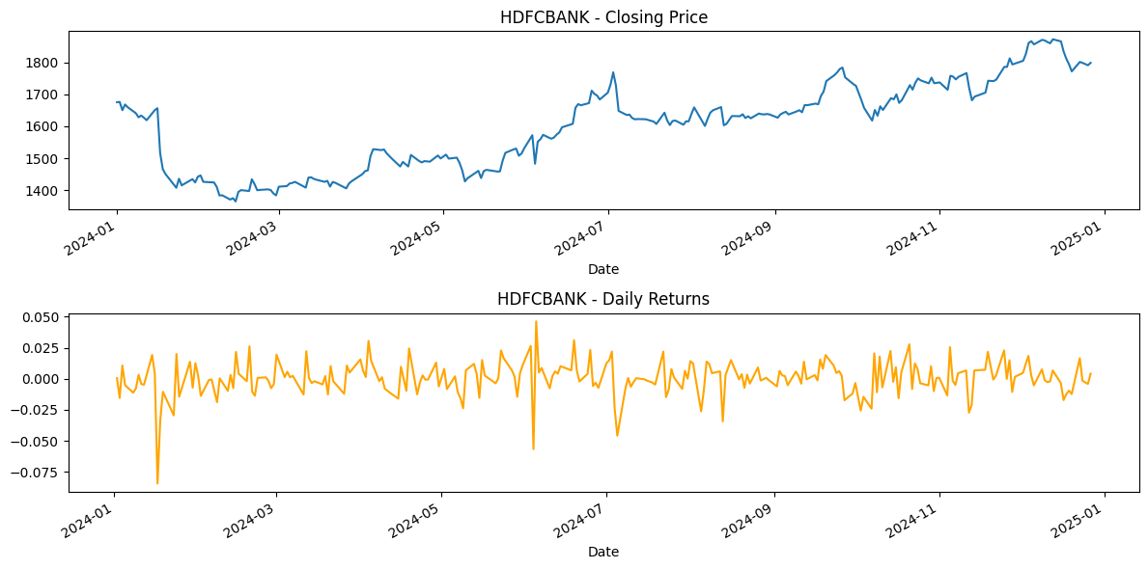

# Plot the closing price and daily returns

plt.figure(figsize=(12, 6))

plt.subplot(2, 1, 1)

ICICI['Close'].plot(title="ICICIBANK - Closing Price")

plt.subplot(2, 1, 2)

ICICI['Daily Return'].plot(title="ICICIBANK - Daily Returns", color='orange')

plt.tight_layout()

plt.show()

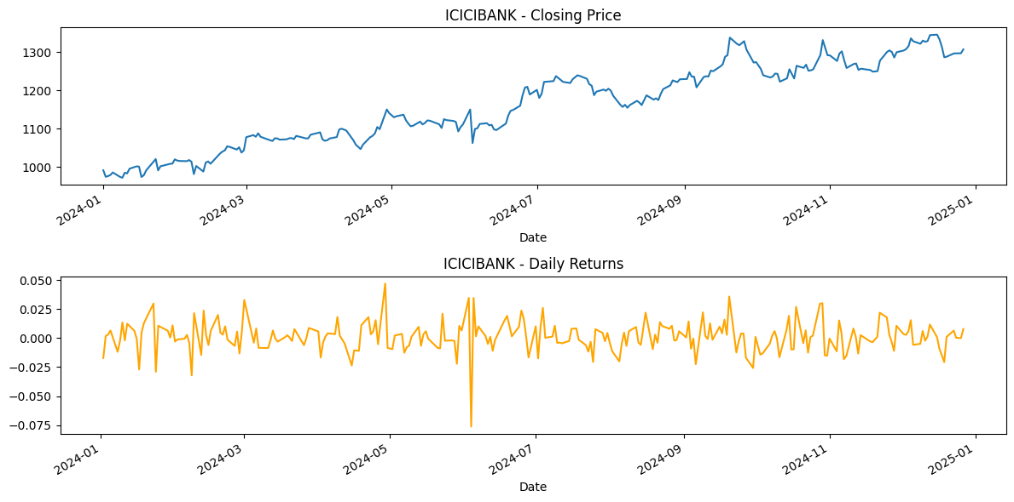

# Plot the closing price and daily returns

plt.figure(figsize=(12, 6))

plt.subplot(2, 1, 1)

KOTAKBANK['Close'].plot(title="KOTAKBANK - Closing Price")

plt.subplot(2, 1, 2)

KOTAKBANK['Daily Return'].plot(title="KOTAKBANK - Daily Returns", color='orange')

plt.tight_layout()

plt.show()

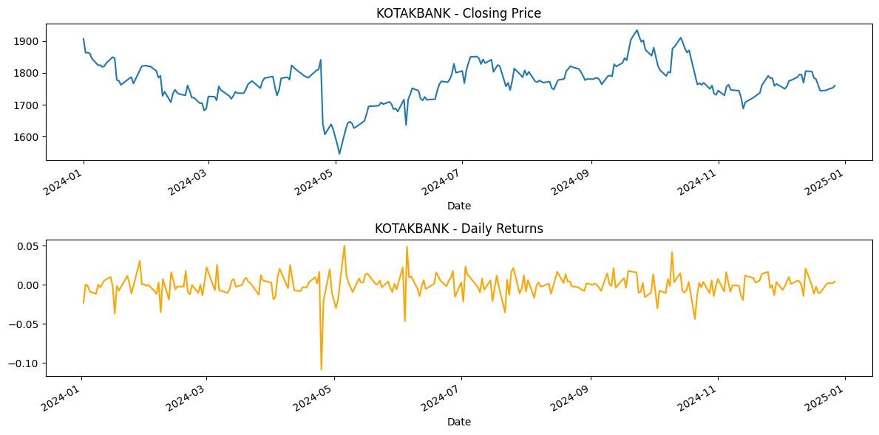

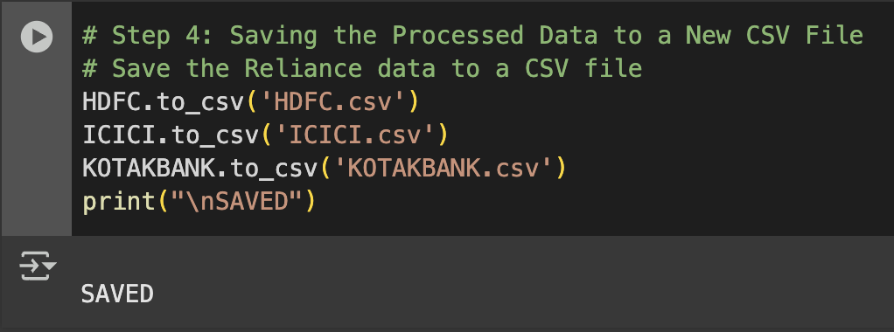

##### Program 2

Demonstrate various data pre-processing techniques for a given dataset.

**Screenshots**

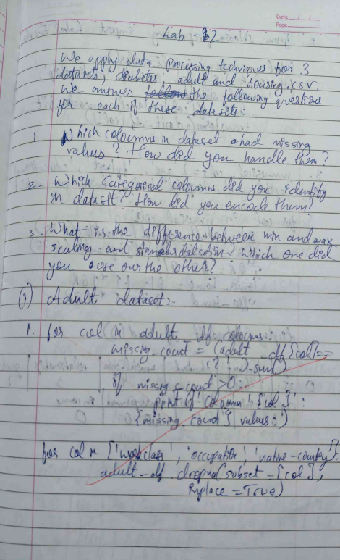

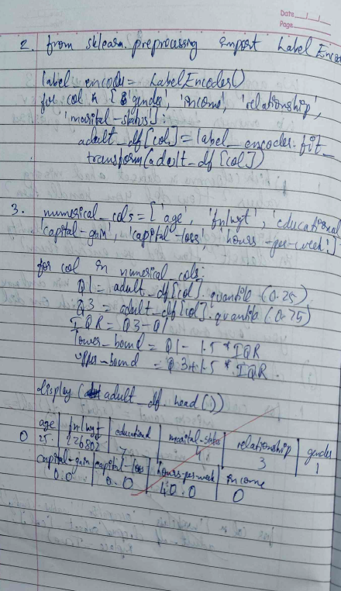

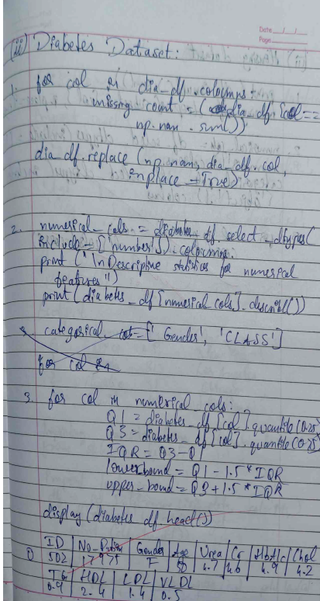

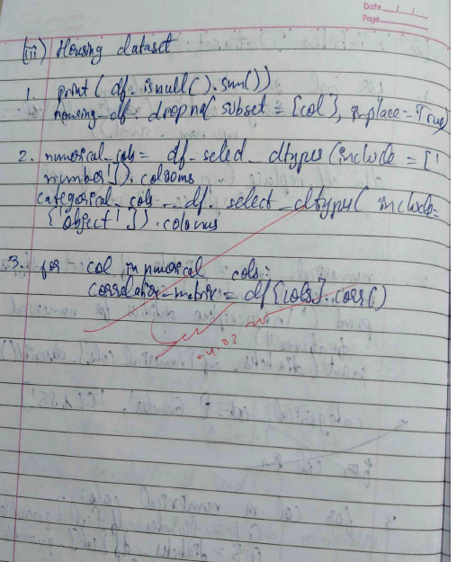

**Code:**

import pandas as pd

file_path = '/content/housing.csv'

df = pd.read_csv(file_path)

print("Sample data:")

print(df.head())

print("\n")

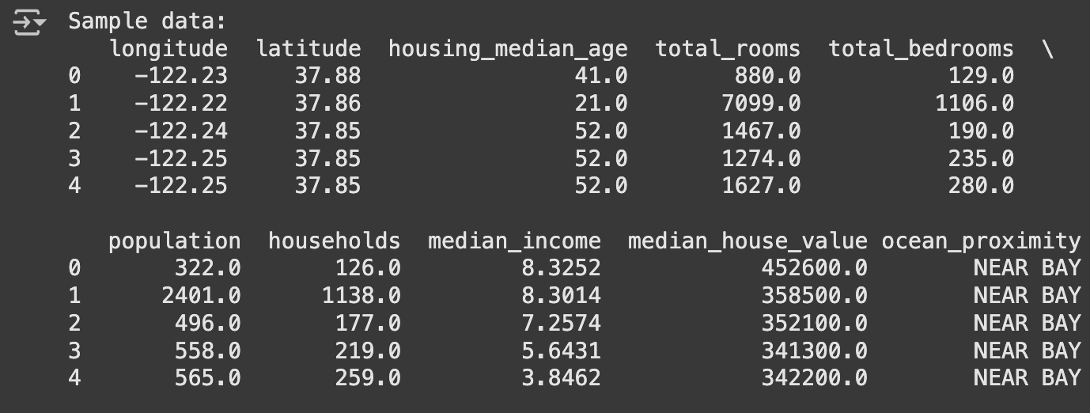

#To display information of all columns

print([df.info](http://df.info))

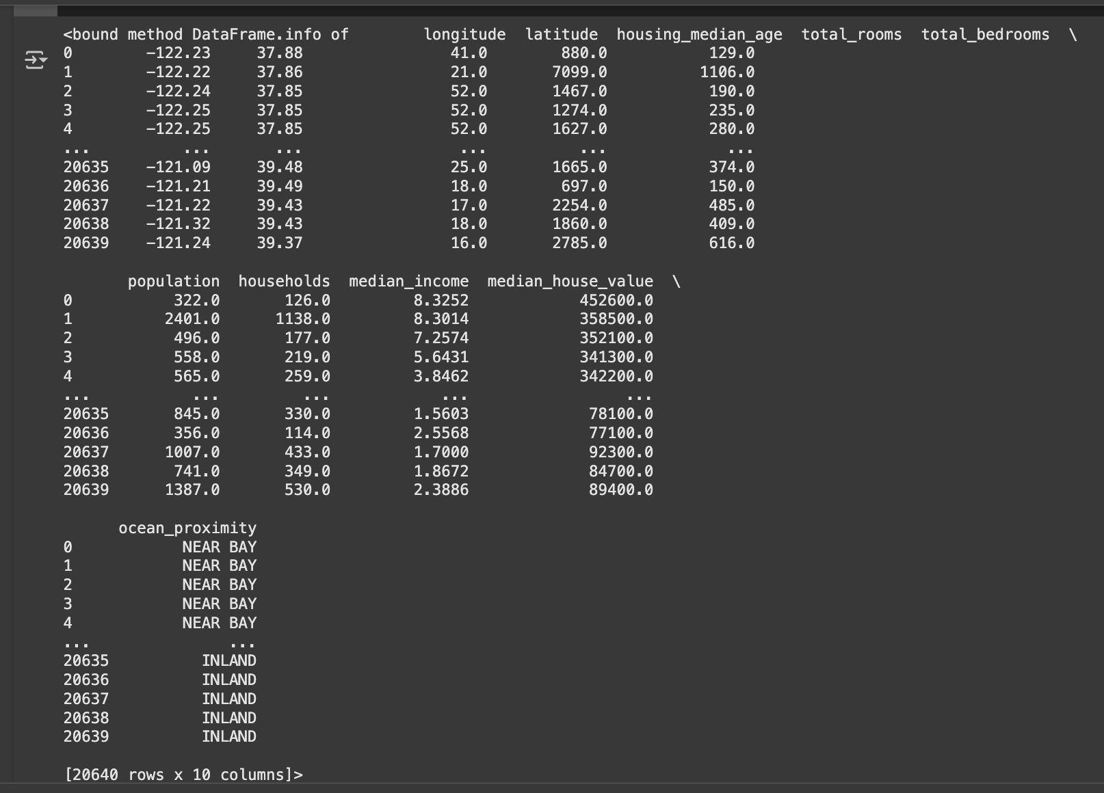

#To display statistical information of all numerical

print(df.describe())

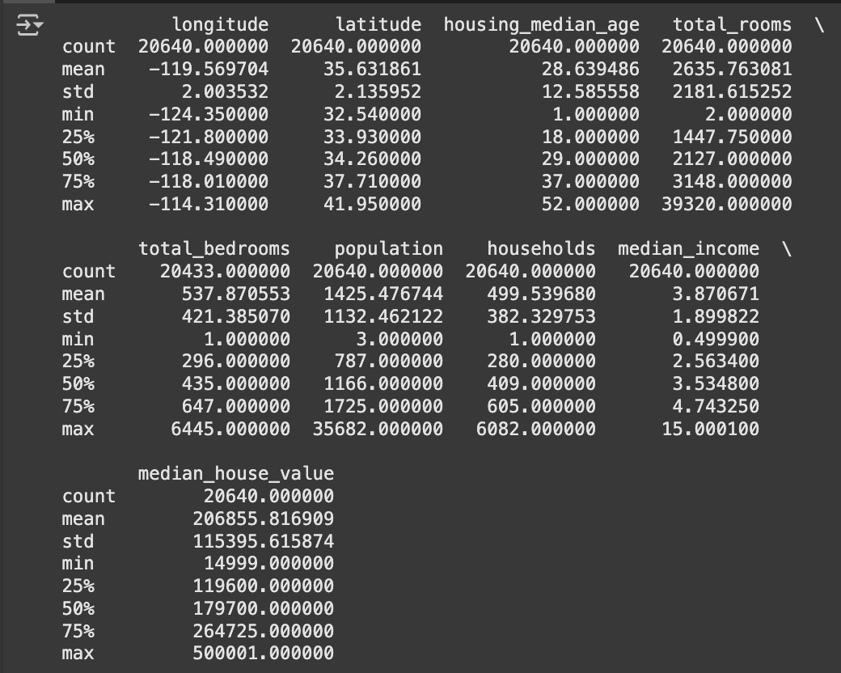

#To display the count of unique labels for “Ocean Proximity” column

print(df['ocean_proximity'].value_counts())

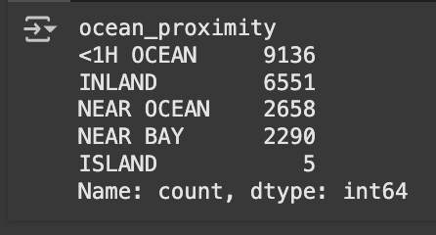

#To display which attributes (columns) in a dataset have missing values count greater than zero

print(df.isnull().sum())

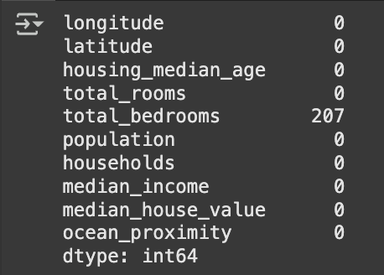

import pandas as pd

import numpy as np

import matplotlib.pyplot as plt

from sklearn.model_selection import train_test_split

from sklearn.impute import SimpleImputer

from sklearn.preprocessing import OrdinalEncoder, OneHotEncoder

from sklearn.preprocessing import StandardScaler, MinMaxScaler

from scipy import stats

def createdata():

data = {

'Age': np.random.randint(18, 70, size=20),

'Salary': np.random.randint(30000, 120000, size=20),

'Purchased': np.random.choice([0, 1], size=20),

'Gender': np.random.choice(['Male', 'Female'], size=20),

'City': np.random.choice(['New York', 'San Francisco', 'Los Angeles'], size=20)

}

df = pd.DataFrame(data)

return df

Vdf = createdata()

df.head(10)

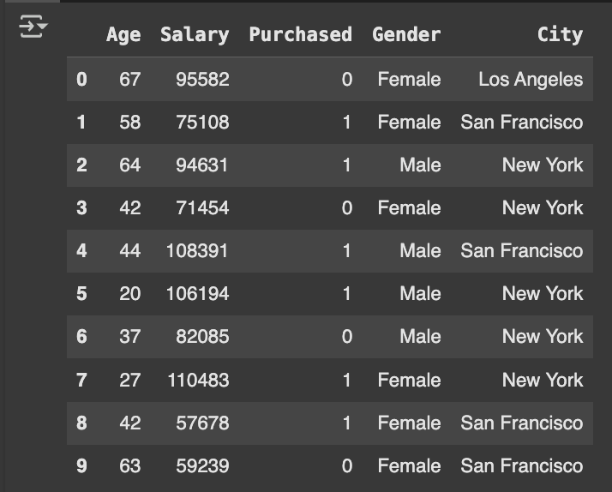

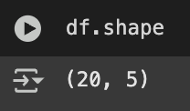

# Introduce some missing values for demonstration

df.loc[5, 'Age'] = np.nan

df.loc[10, 'Salary'] = np.nan

df.head(10)

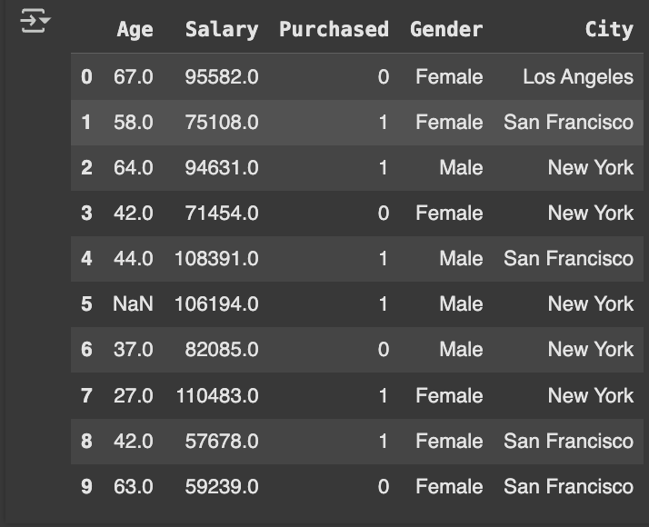

# Basic information about the dataset

print([df.info](http://df.info)())

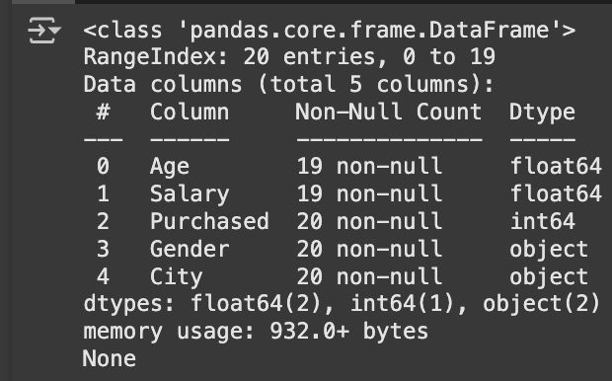

# Summary statistics

print(df.describe())

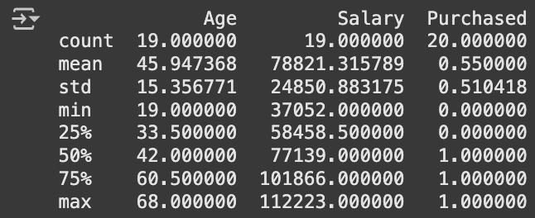

#Code to Find Missing Values

# Check for missing values in each column

missing_values = df.isnull().sum()

# Display columns with missing values

print(missing_values[missing_values > 0])

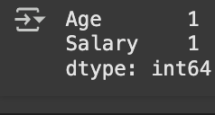

#Set the values to some value (zero, the mean, the median, etc.).

# Step 1: Create an instance of SimpleImputer with the median strategy for Age and mean stratergy for Salary

imputer1 = SimpleImputer(strategy="median")

imputer2 = SimpleImputer(strategy="mean")

df_copy=df

# Step 2: Fit the imputer on the "Age" and "Salary"column

# Note: SimpleImputer expects a 2D array, so we reshape the column

imputer1.fit(df_copy[["Age"]])

imputer2.fit(df_copy[["Salary"]])

# Step 3: Transform (fill) the missing values in the "Age" and "Salary"c column

df_copy["Age"] = imputer1.transform(df[["Age"]])

df_copy["Salary"] = imputer2.transform(df[["Salary"]])

# Verify that there are no missing values left

print(df_copy["Age"].isnull().sum())

print(df_copy["Salary"].isnull().sum())

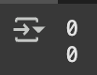

#Handling Categorical Attributes

#Using Ordinal Encoding for gender COlumn and One-Hot Encoding for City Column

# Initialize OrdinalEncoder

ordinal_encoder = OrdinalEncoder(categories=[["Male", "Female"]])

# Fit and transform the data

df_copy["Gender_Encoded"] = ordinal_encoder.fit_transform(df_copy[["Gender"]])

# Initialize OneHotEncoder

onehot_encoder = OneHotEncoder()

# Fit and transform the "City" column

encoded_data = onehot_encoder.fit_transform(df[["City"]])

# Convert the sparse matrix to a dense array

encoded_array = encoded_data.toarray()

# Convert to DataFrame for better visualization

encoded_df = pd.DataFrame(encoded_array, columns=onehot_encoder.get_feature_names_out(["City"]))

df_encoded = pd.concat([df_copy, encoded_df], axis=1)

df_encoded.drop("Gender", axis=1, inplace=True)

df_encoded.drop("City", axis=1, inplace=True)

print(df_encoded. head())

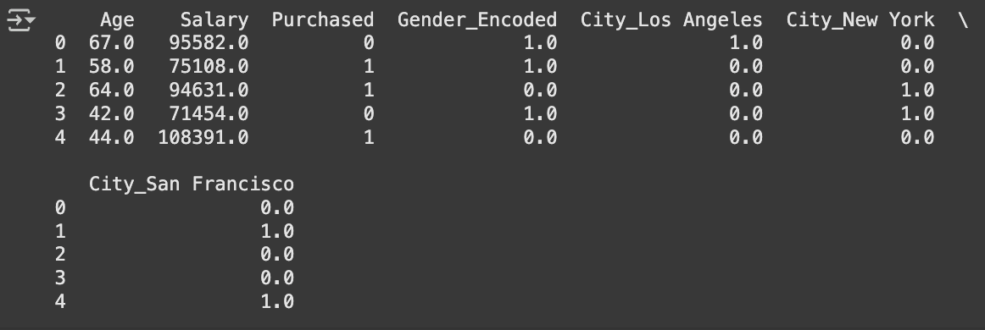

#Data Transformation

# Min-Max Scaler/Normalization (range 0-1)

#Pros: Keeps all data between 0 and 1; ideal for distance-based models.

#Cons: Can distort data distribution, especially with extreme outliers.

normalizer = MinMaxScaler()

df_encoded[['Salary']] = normalizer.fit_transform(df_encoded[['Salary']])

df_encoded.head()

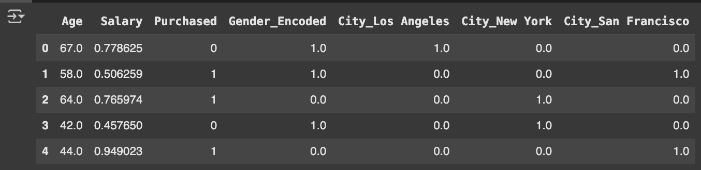

# Standardization (mean=0, variance=1)

#Pros: Works well for normally distributed data; suitable for many models.

#Cons: Sensitive to outliers.

scaler = StandardScaler()

df_encoded[['Age']] = scaler.fit_transform(df_encoded[['Age']])

df_encoded.head()

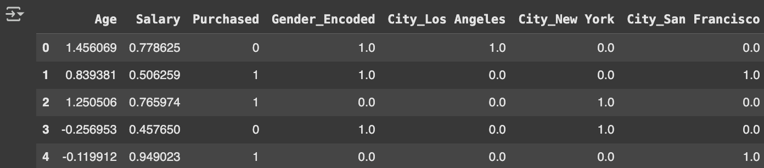

#Removing Outliers

# Outlier Detection and Treatment using IQR

#Pros: Simple and effective for mild outliers.

#Cons: May overly reduce variation if there are many extreme outliers.

df_encoded_copy1=df_encoded

df_encoded_copy2=df_encoded

df_encoded_copy3=df_encoded

Q1 = df_encoded_copy1['Salary'].quantile(0.25)

Q3 = df_encoded_copy1['Salary'].quantile(0.75)

IQR = Q3 - Q1

lower_bound = Q1 - 1.5 * IQR

upper_bound = Q3 + 1.5 * IQR

df_encoded_copy1['Salary'] = np.where(df_encoded_copy1['Salary'] > upper_bound, upper_bound,

np.where(df_encoded_copy1['Salary'] < lower_bound, lower_bound, df_encoded_copy1['Salary']))

print(df_encoded_copy1.head())

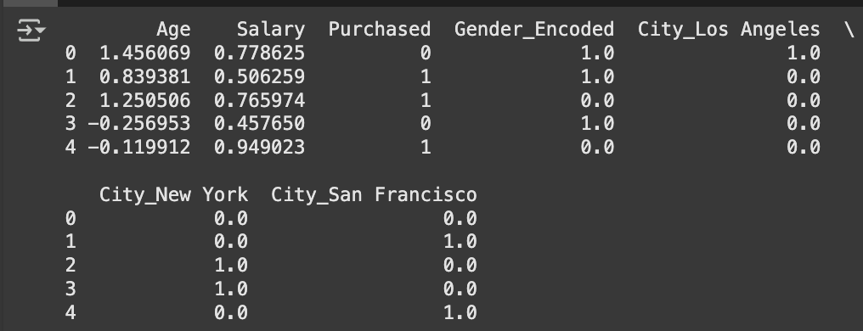

#Removing Outliers

# Z-score method

#Pros: Good for normally distributed data.

#Cons: Not suitable for non-normal data; may miss outliers in skewed distributions.

df_encoded_copy2['Salary_zscore'] = stats.zscore(df_encoded_copy2['Salary'])

df_encoded_copy2['Salary'] = np.where(df_encoded_copy2['Salary_zscore'].abs() > 3, np.nan, df_encoded_copy2['Salary']) # Replace outliers with NaN

print(df_encoded_copy2.head())

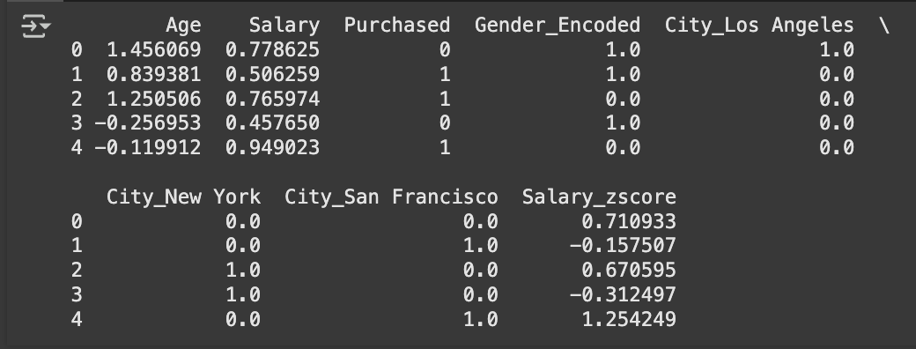

#Removing Outliers

# Median replacement for outliers

#Pros: Keeps distribution shape intact, useful when capping isn’t feasible.

#Cons: May distort data if outliers represent real phenomena.

df_encoded_copy3['Salary_zscore'] = stats.zscore(df_encoded_copy3['Salary'])

median_salary = df_encoded_copy3['Salary'].median()

df_encoded_copy3['Salary'] = np.where(df_encoded_copy3['Salary_zscore'].abs() > 3, median_salary, df_encoded_copy3['Salary'])

print(df_encoded_copy3.head())

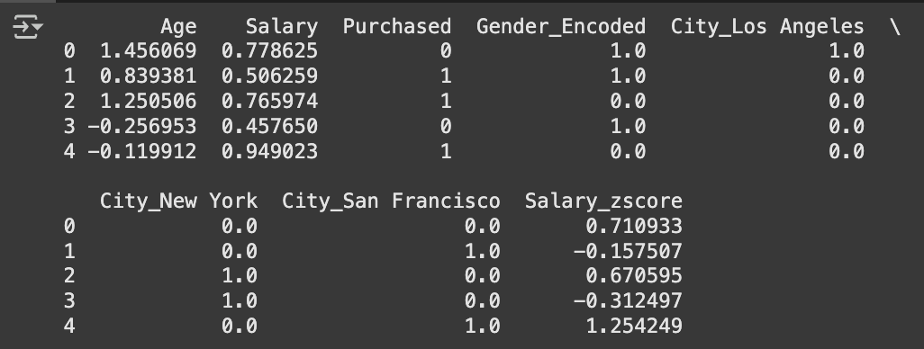

* **Diabetes**

import pandas as pd

file_path = '/content/Dataset of Diabetes .csv'

df = pd.read_csv(file_path)

print("Sample data:")

print(df.head())

print("\n")

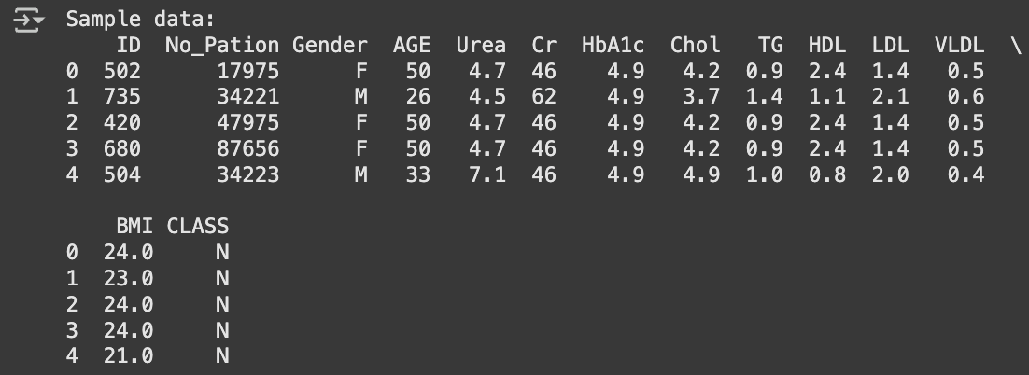

#1. Which columns in the dataset had missing values? How did you handle them ?

print(df.isnull().sum())

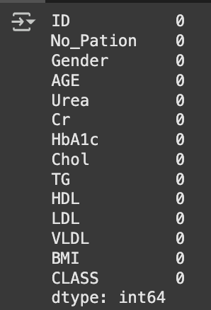

#2. Which categorical columns did you identify in the dataset? How did you encode them ?

print([df.info](http://df.info))

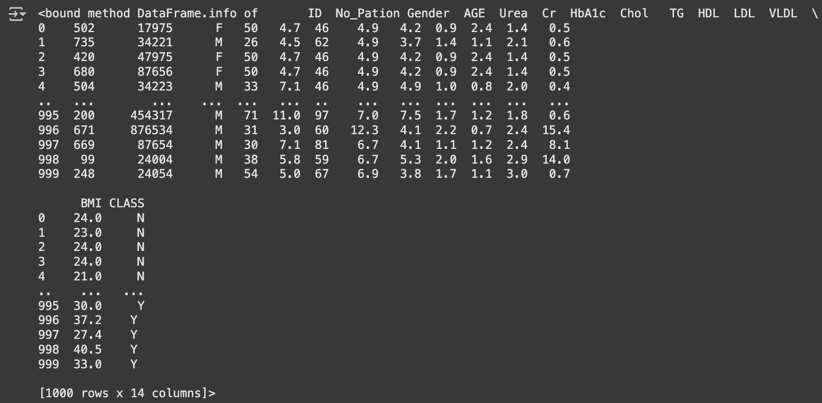

# Clean the Gender column: Convert all values to uppercase

df["Gender"] = df["Gender"].str.upper()

# Initialize OrdinalEncoder for Gender

ordinal_encoder = OrdinalEncoder(categories=[["F", "M"]], handle_unknown="use_encoded_value", unknown_value=-1)

# Fit and transform the Gender column

df["Gender_Encoded"] = ordinal_encoder.fit_transform(df[["Gender"]])

# Initialize OneHotEncoder for CLASS

onehot_encoder = OneHotEncoder()

# Fit and transform the CLASS column

encoded_data = onehot_encoder.fit_transform(df[["CLASS"]])

# Convert the sparse matrix to a dense array

encoded_array = encoded_data.toarray()

# Convert to DataFrame for better visualization

encoded_df = pd.DataFrame(encoded_array, columns=onehot_encoder.get_feature_names_out(["CLASS"]))

df_encoded = pd.concat([df, encoded_df], axis=1)

# Drop the original Gender and CLASS columns

df_encoded.drop("Gender", axis=1, inplace=True)

df_encoded.drop("CLASS", axis=1, inplace=True)

print(df_encoded.head())

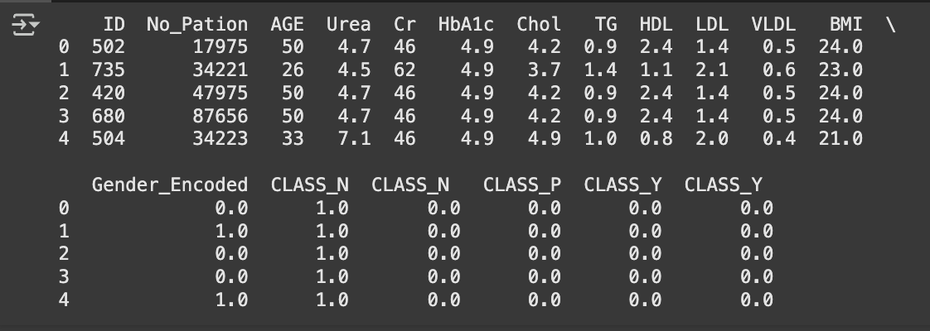

* **ADULT INCOME DATA**

import pandas as pd

file_path = '/content/adult.csv'

df = pd.read_csv(file_path)

print("Sample data:")

print(df.head())

print("\n")

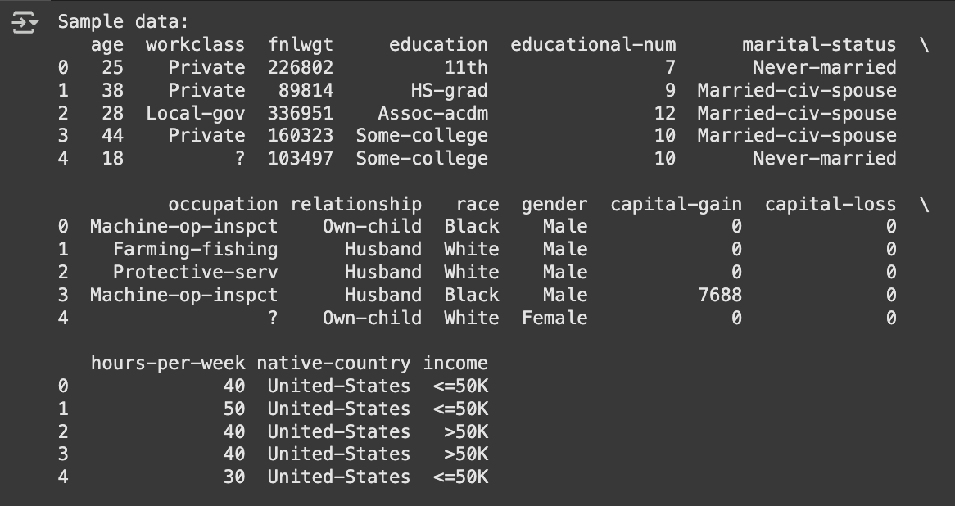

print(df.isnull().sum())

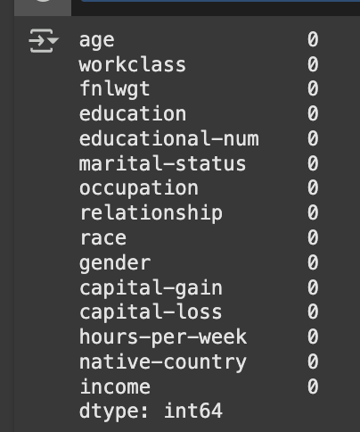

print([df.info](http://df.info))

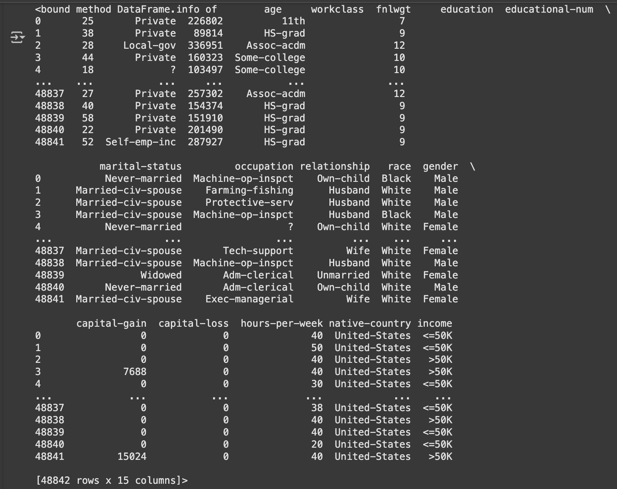

# Encode binary categorical columns (e.g., gender) using OrdinalEncoder

binary_columns = ['gender']

# Initialize OrdinalEncoder for binary columns

ordinal_encoder = OrdinalEncoder(categories=[["Female", "Male"]], handle_unknown="use_encoded_value", unknown_value=-1)

df[binary_columns] = ordinal_encoder.fit_transform(df[binary_columns])

# Encode multi-category columns using OneHotEncoder

multi_category_columns = ['workclass', 'education', 'marital-status', 'occupation', 'relationship', 'race', 'native-country']

onehot_encoder = OneHotEncoder(sparse_output=False, drop='first') # Drop first column to avoid multicollinearity

encoded_data = onehot_encoder.fit_transform(df[multi_category_columns])

# Convert encoded data to DataFrame

encoded_df = pd.DataFrame(encoded_data, columns=onehot_encoder.get_feature_names_out(multi_category_columns))

# Concatenate encoded data with the original DataFrame

df_encoded = pd.concat([df.drop(multi_category_columns, axis=1), encoded_df], axis=1)

# Display the encoded DataFrame

print("\nEncoded DataFrame:")

print(df_encoded.head())

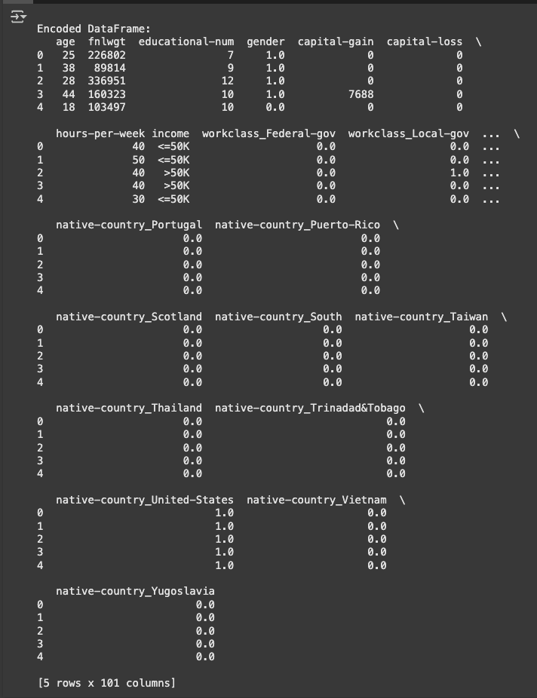

##### Program 3

Implement Linear and Multi-Linear Regression algorithm using appropriate dataset

**Screenshots**

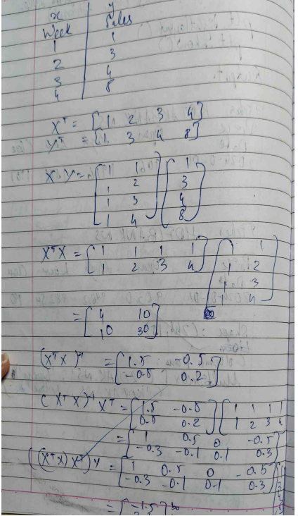

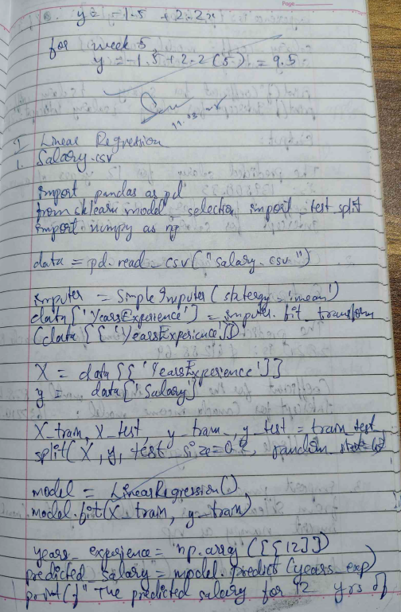

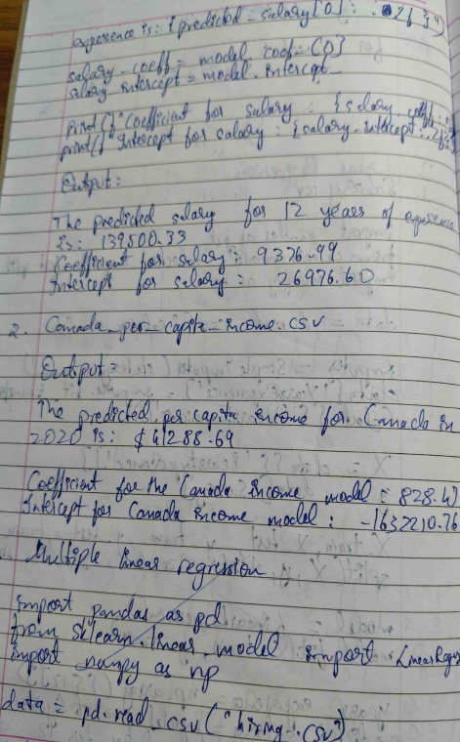

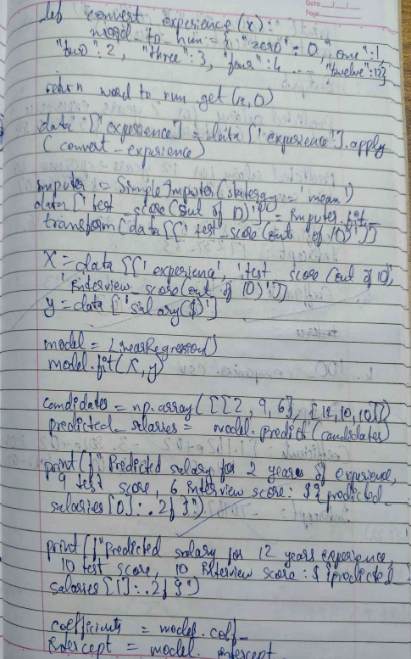

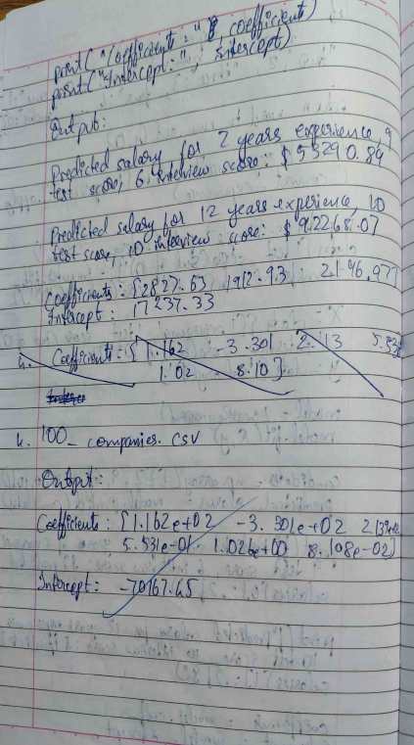

**Code:**

**Linear Regression:**

import numpy as np

import pandas as pd

from sklearn.model_selection import train_test_split

from sklearn.linear_model import LinearRegression

from sklearn.datasets import fetch_california_housing

# Load the California Housing dataset

california_housing = fetch_california_housing()

# Assign the data (features) and target (house prices)

X = pd.DataFrame(california_housing.data, columns=california_housing.feature_names)

y = pd.Series(california_housing.target)

# Select features for Linear Regression

X = X[['MedInc', 'AveRooms']]

# Split the data into training and testing sets

X_train, X_test, y_train, y_test = train_test_split(X, y, test_size=0.2, random_state=42)

# Create and train the Linear Regression model

model = LinearRegression()

model.fit(X_train, y_train)

# Make predictions

y_pred = model.predict(X_test)

# Print the actual vs predicted values

results = pd.DataFrame({'Actual': y_test, 'Predicted': y_pred})

print("Linear Regression Results:")

print(results.head())

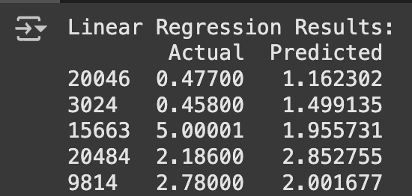

**Multiple Regression:**

import numpy as np

import pandas as pd

import matplotlib.pyplot as plt

from sklearn.model_selection import train_test_split

from sklearn.linear_model import LinearRegression

from sklearn.datasets import fetch_california_housing

california_housing = fetch_california_housing()

X = pd.DataFrame(california_housing.data, columns=california_housing.feature_names)

y = pd.Series(california_housing.target)

X = X[['MedInc', 'AveRooms']]

X_train, X_test, y_train, y_test = train_test_split(X, y, test_size=0.2, random_state=42)

model = LinearRegression()

model.fit(X_train, y_train)

y_pred = model.predict(X_test)

# Print the actual vs predicted values

results = pd.DataFrame({'Actual': y_test, 'Predicted': y_pred})

print(results.head())

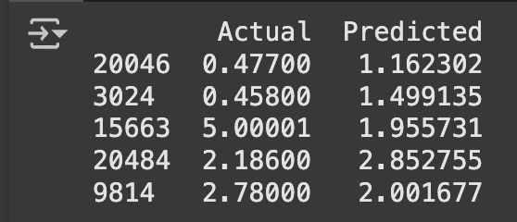

##### 

##### 

##### 

##### 

##### Program 4

Build Logistic Regression Model for a given dataset

**Screenshots**

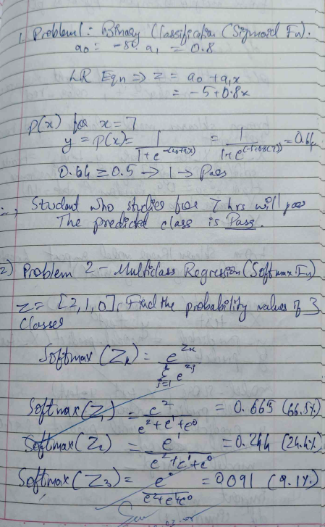

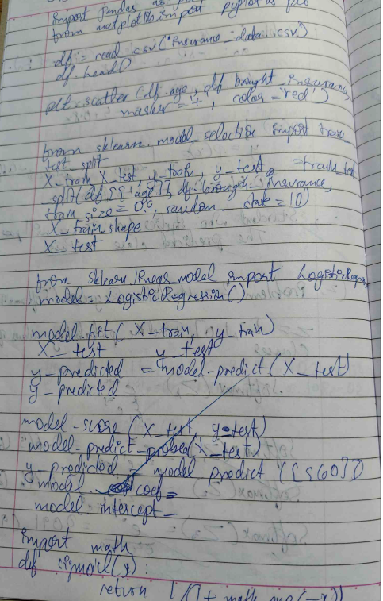

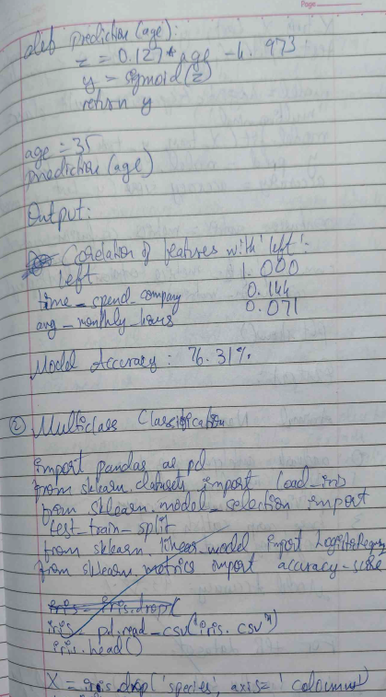

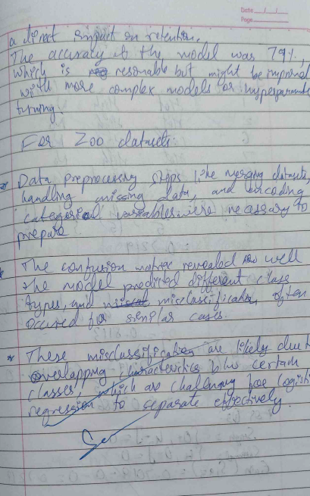

**Code:**

import numpy as np

import pandas as pd

from sklearn.model_selection import train_test_split

from sklearn.linear_model import LogisticRegression

from sklearn.datasets import load_iris

# Load the Iris dataset

iris = load_iris()

# Assign the data (features) and target (species)

X = pd.DataFrame(iris.data, columns=iris.feature_names)

y = pd.Series(iris.target)

# For simplicity, we will classify only two classes (0 and 1)

X = X[y.isin([0, 1])] # Select only classes 0 and 1

y = y[y.isin([0, 1])]

# Split the data into training and testing sets

X_train, X_test, y_train, y_test = train_test_split(X, y, test_size=0.2, random_state=42)

# Create and train the Logistic Regression model

model = LogisticRegression()

model.fit(X_train, y_train)

# Make predictions

y_pred = model.predict(X_test)

# Print the actual vs predicted values

results = pd.DataFrame({'Actual': y_test, 'Predicted': y_pred})

print("Logistic Regression Results:")

print(results.head())

##### Program 5

Use an appropriate data set for building the decision tree (ID3) and apply this knowledge to classify a new sample

**Screenshots**

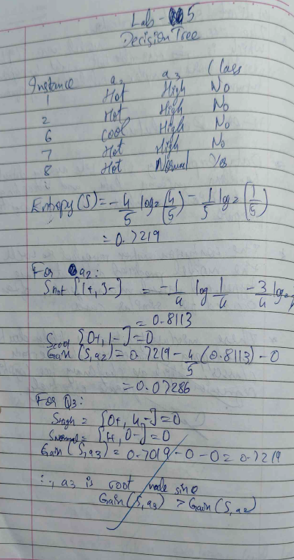

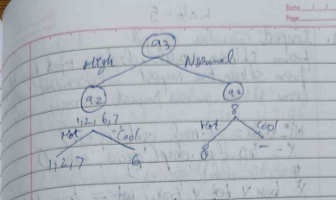

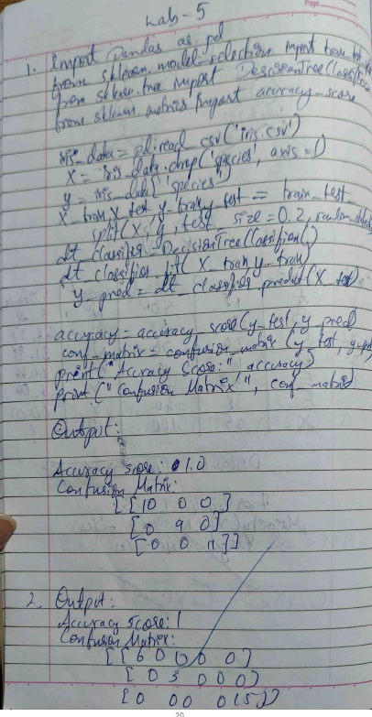

**Code:**

import pandas as pd

data = {

'Outlook': ['Sunny', 'Sunny', 'Overcast', 'Rainy', 'Rainy', 'Rainy', 'Overcast', 'Sunny', 'Sunny', 'Rainy', 'Sunny', 'Overcast', 'Overcast', 'Rainy'],

'Temperature': ['Hot', 'Hot', 'Hot', 'Mild', 'Cool', 'Cool', 'Cool','Mild', 'Cool','Mild', 'Mild', 'Mild', 'Hot', 'Mild'],

'Humidity': ['High', 'High', 'High', 'High', 'Normal', 'Normal', 'Normal', 'High', 'Normal', 'Normal', 'Normal', 'High', 'Normal', 'High'],

'Windy': ['Weak', 'Strong', 'Weak', 'Weak', 'Weak', 'Strong', 'Strong', 'Weak', 'Weak', 'Weak', 'Strong', 'Strong', 'Weak', 'Strong'],

'PlayTennis': ['No', 'No', 'Yes', 'Yes', 'Yes', 'No', 'Yes', 'No', 'Yes', 'Yes', 'Yes', 'Yes', 'Yes', 'No']

}

df = pd.DataFrame(data)

import math

def entropy(data):

total = len(data)

counts = data.value_counts()

entropy_value = 0

for count in counts:

probability = count / total

entropy_value -= probability * math.log2(probability)

return entropy_value

def information_gain(data, feature, target):

total_entropy = entropy(data[target])

feature_values = data[feature].unique()

weighted_entropy = 0

for value in feature_values:

subset = data[data[feature] == value]

weighted_entropy += (len(subset) / len(data)) * entropy(subset[target])

return total_entropy - weighted_entrop

def best_split(data, target):

features = data.drop(columns=[target]).columns

best_feature = None

best_gain = -1

for feature in features:

gain = information_gain(data, feature, target)

if gain > best_gain:

best_gain = gain

best_feature = feature

return best_feature

def best_split(data, target):

features = data.drop(columns=[target]).columns

best_feature = None

best_gain = -1

for feature in features:

gain = information_gain(data, feature, target)

if gain > best_gain:

best_gain = gain

best_feature = feature

return best_feature

# Build the decision tree using the dataset

tree = build_tree(df, target='PlayTennis')

print(tree)



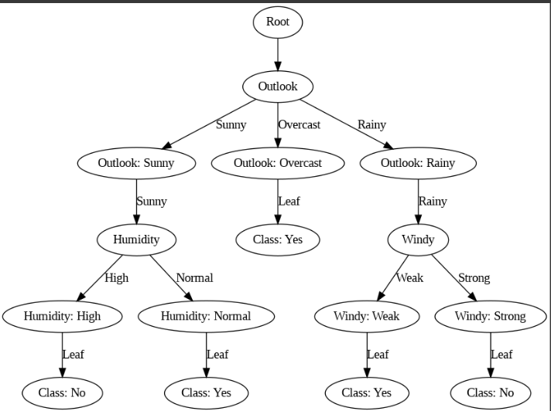

* **California Housing Prices (Splitting)**

import pandas as pd

housing = pd.read_csv("housing.csv")

housing.head()

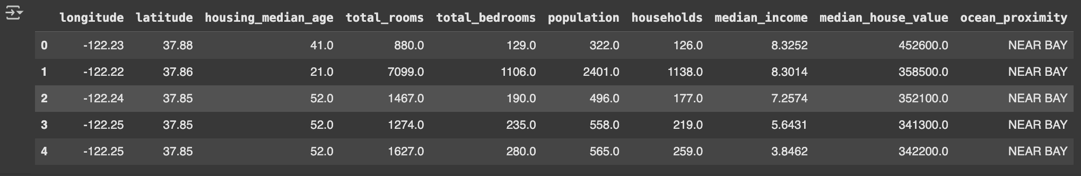

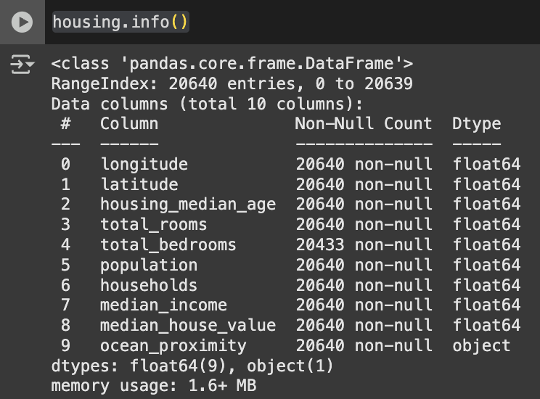

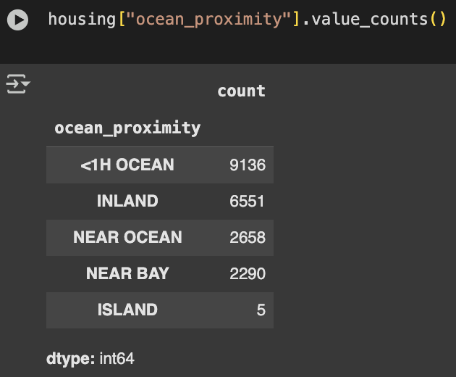

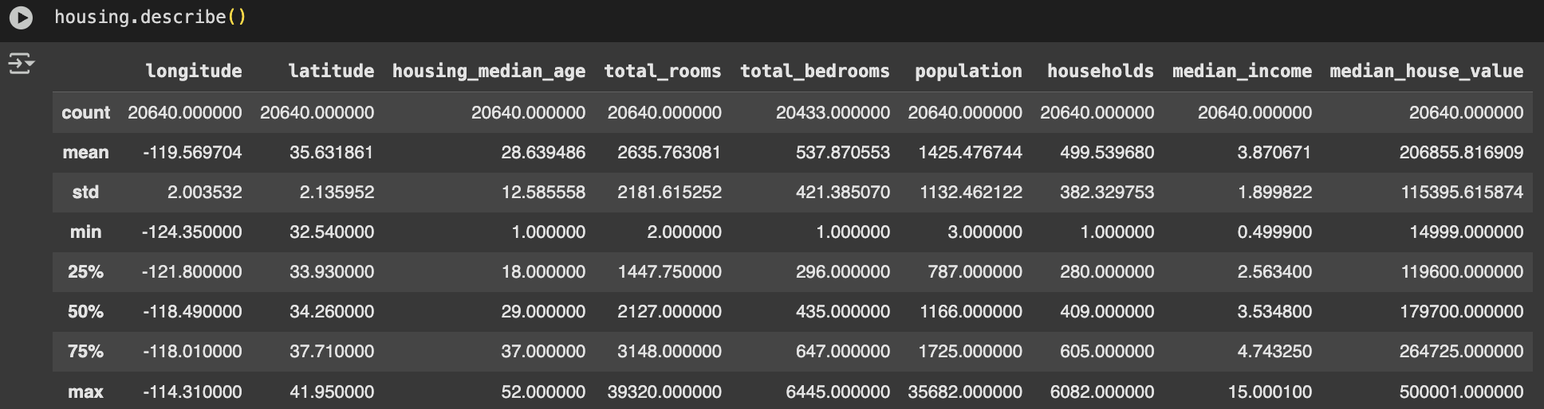

import matplotlib.pyplot as plt

# Plot a histogram of median house values

housing['median_house_value'].hist(bins=50, figsize=(10, 6))

plt.xlabel("Median House Value")

plt.ylabel("Frequency")

plt.title("Distribution of Median House Values")

plt.show()

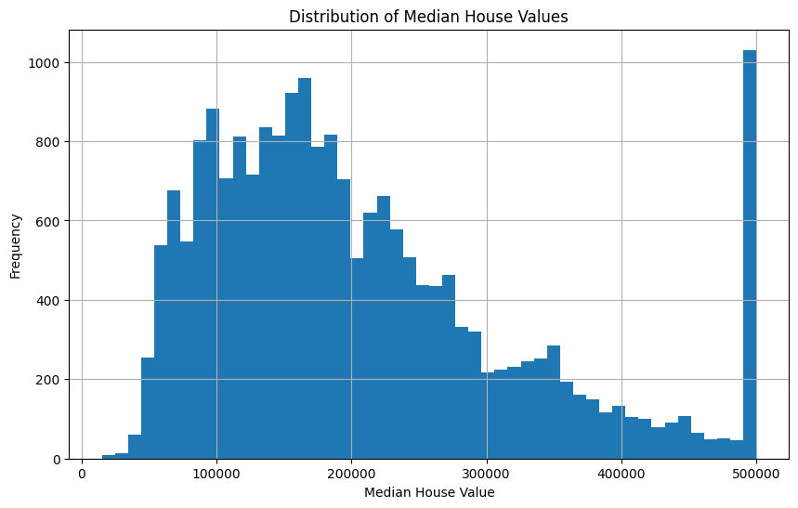

import pandas as pd

from sklearn.model_selection import train_test_split

housing = pd.read_csv("housing.csv")

# Random sampling

train_set, test_set = train_test_split(housing, test_size=0.2, random_state=42)

X_train, X_test, y_train, y_test = train_test_split(X, y, test_size=0.2, random_state=42, stratify=y)

# Separate into features (X) and target (y)

X = housing.drop("median_house_value", axis=1) # Features (all columns except the target)

y = housing["median_house_value"] # Target variable

# Split into train and test sets with stratification

X_train, X_test, y_train, y_test = train_test_split(X, y, test_size=0.2, random_state=42)

import pandas as pd

from sklearn.model_selection import train_test_split

# Separate into features (X) and target (y)

X = housing.drop("median_house_value", axis=1) # Features (all columns except the target)

y = housing["median_house_value"] # Target variable

# Create categories for the target variable

housing["income_cat"] = pd.cut(housing["median_house_value"],

bins=[0, 100000, 200000, 300000, 400000, np.inf],

labels=[1, 2, 3, 4, 5])

# Split into train and test sets with stratification

X_train, X_test, y_train, y_test = train_test_split(X, y, test_size=0.2, random_state=42, stratify=housing["income_cat"])

import matplotlib.pyplot as plt

# Add the target variable back to the training set for visualization

train_set = X_train.copy()

train_set["median_house_value"] = y_train

# Plot the training set

train_set.plot(kind="scatter", x="longitude", y="latitude")

plt.legend()

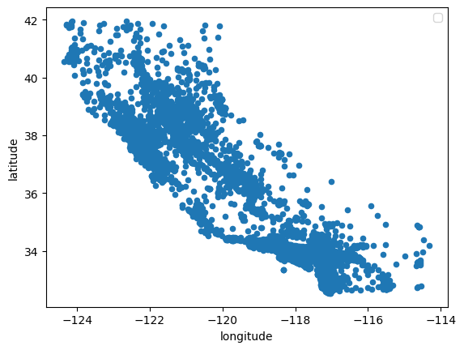

import matplotlib.pyplot as plt

# Add the target variable back to the training set for visualization

train_set = X_train.copy()

train_set["median_house_value"] = y_train

# Plot the training set

train_set.plot(kind="scatter", x="longitude", y="latitude",alpha=0.1)

plt.legend()

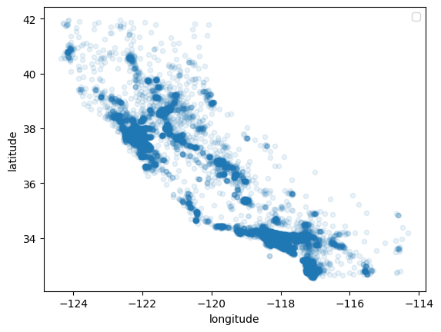

train_set.plot(kind="scatter", x="longitude", y="latitude", alpha=0.4, s=train_set["population"]/100, label="population", figsize=(10,7), c="median_house_value", cmap=plt.get_cmap("jet"), colorbar=True)

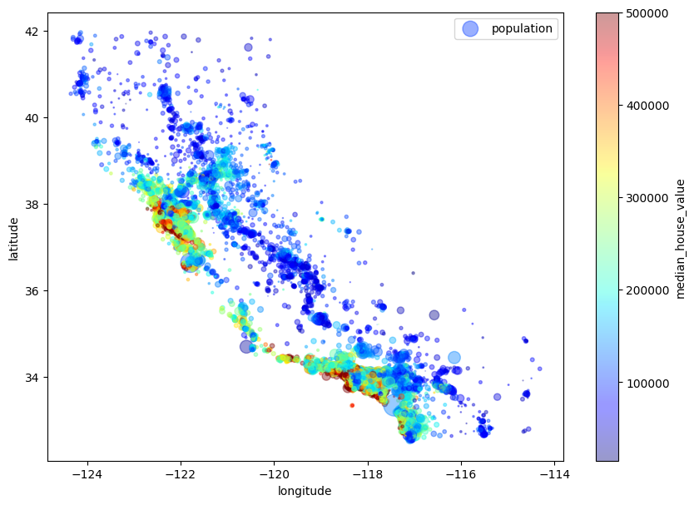

# Select only numerical columns (excluding categorical columns like 'ocean_proximity')

numerical_columns = housing.select_dtypes(include=['float64', 'int64'])

# Calculate the correlation matrix

correlation_matrix = numerical_columns.corr()

# Display the correlation of 'median_house_value' with other numerical columns

print(correlation_matrix["median_house_value"].sort_values(ascending=False))

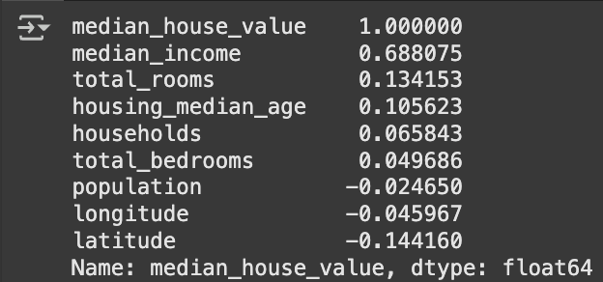

housing.plot(kind="scatter", x="median_income", y="median_house_value", alpha=0.1)

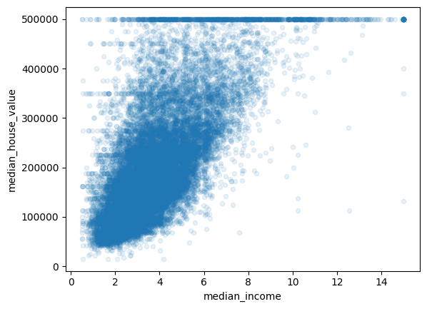

##### Program 6

Build KNN Classification model for a given dataset

**Screenshots**

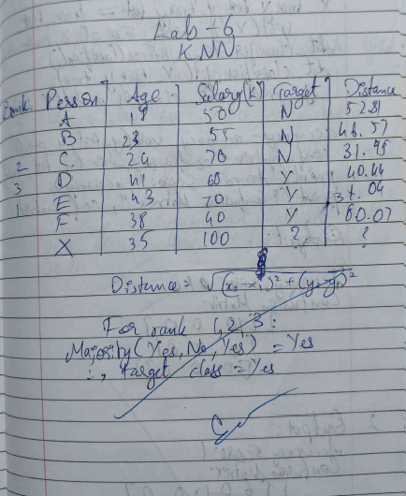

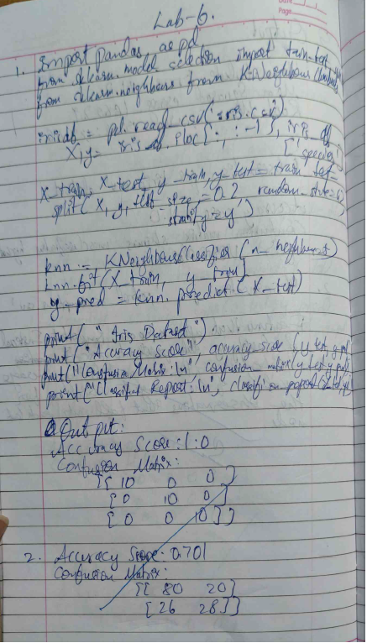

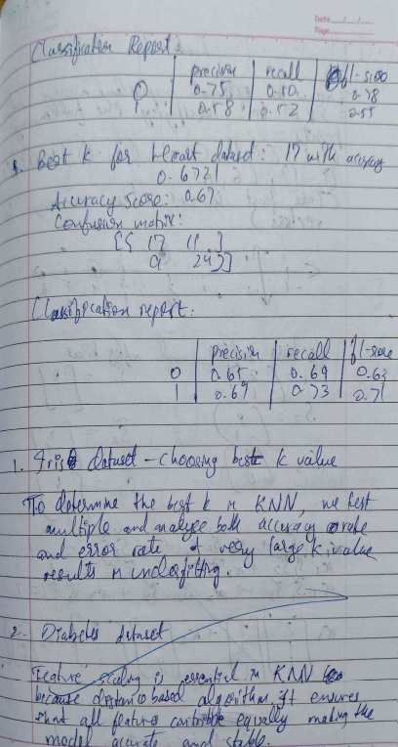

**Code:**

*Using Iris Dataset and visualizing:*

import numpy as np

import matplotlib.pyplot as plt

from sklearn import datasets

from sklearn.model_selection import train_test_split

from sklearn.neighbors import KNeighborsClassifier

from sklearn.metrics import accuracy_score

# Load the Iris dataset

iris = datasets.load_iris()

X = iris.data[:, :2] # Only use the first two features (sepal length and sepal width)

y = iris.target # Target labels

# Split the dataset into training and testing sets

X_train, X_test, y_train, y_test = train_test_split(X, y, test_size=0.3, random_state=42)

# Create the KNN classifier (k=3 for this example)

knn = KNeighborsClassifier(n_neighbors=3)

knn.fit(X_train, y_train)

y_pred_knn = knn.predict(X_test)

# Create a mesh grid for plotting decision boundaries

x_min, x_max = X[:, 0].min() - 1, X[:, 0].max() + 1

y_min, y_max = X[:, 1].min() - 1, X[:, 1].max() + 1

xx, yy = np.meshgrid(np.arange(x_min, x_max, 0.01),

np.arange(y_min, y_max, 0.01))

# Plotting the decision boundaries for KNN

plt.figure(figsize=(7, 6))

Z_knn = knn.predict(np.c_[xx.ravel(), yy.ravel()])

Z_knn = Z_knn.reshape(xx.shape)

plt.contourf(xx, yy, Z_knn, alpha=0.4)

plt.scatter(X_train[:, 0], X_train[:, 1], c=y_train, marker='o', label="Train Data")

plt.scatter(X_test[:, 0], X_test[:, 1], c=y_test, marker='x', label="Test Data")

plt.title("KNN Decision Boundary")

plt.xlabel("Sepal Length")

plt.ylabel("Sepal Width")

plt.legend()

plt.show()

# Print accuracy

accuracy_knn = accuracy_score(y_test, y_pred_knn)

print(f"KNN Model Accuracy: {accuracy_knn * 100:.2f}%")

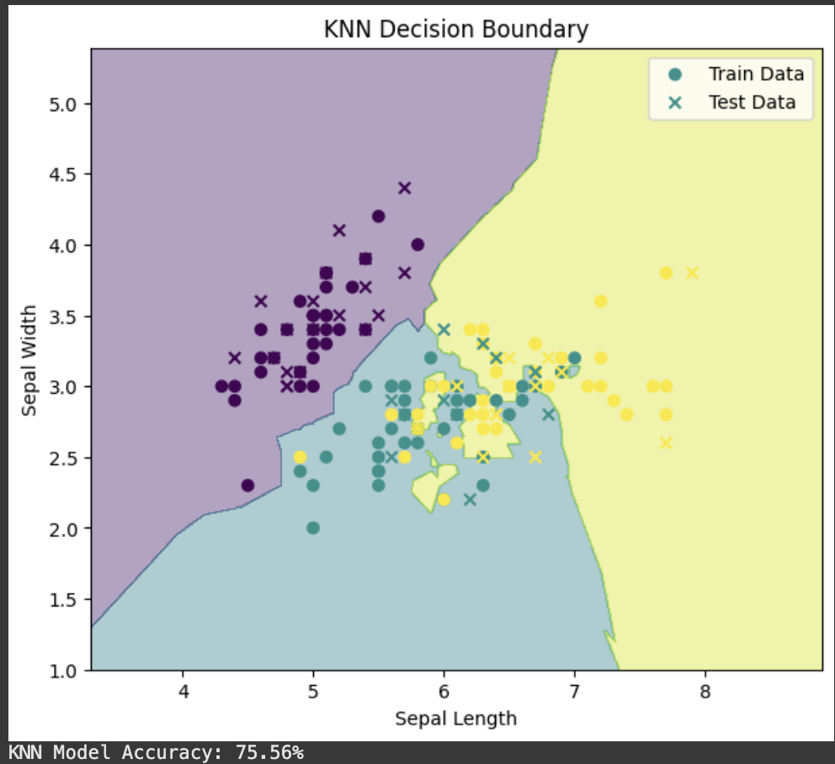

##### Program 7

Build Support vector machine model for a given dataset

**Screenshots**

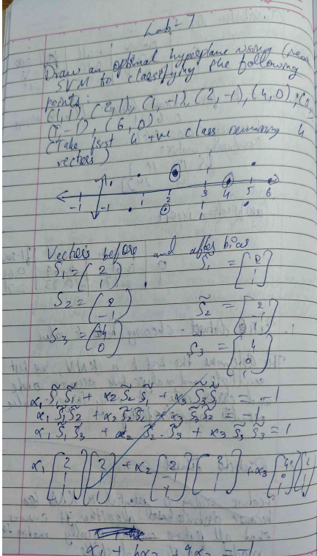

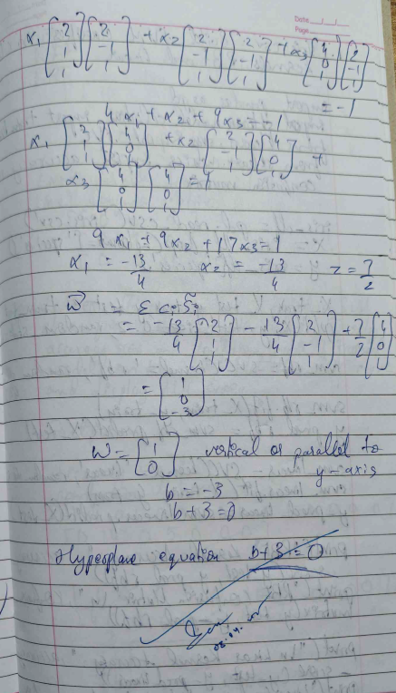

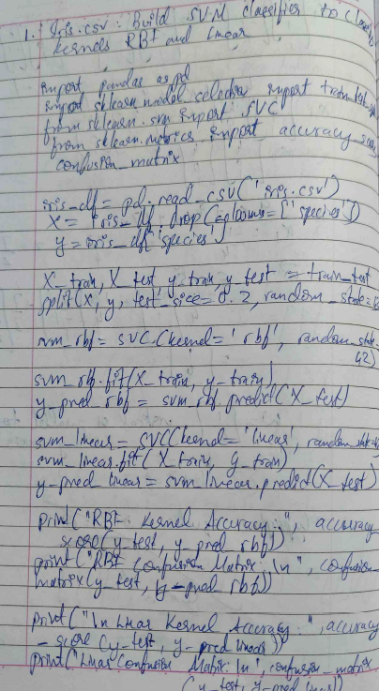

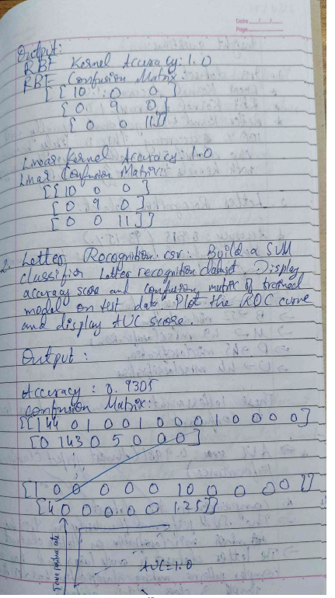

**Code:**

*Using Iris Dataset and visualizing:*

import numpy as np

import matplotlib.pyplot as plt

from sklearn import datasets

from sklearn.model_selection import train_test_split

from sklearn.svm import SVC

from sklearn.metrics import accuracy_score

# Load the Iris dataset

iris = datasets.load_iris()

X = iris.data[:, :2] # Only use the first two features (sepal length and sepal width)

y = iris.target # Target labels

# Split the dataset into training and testing sets

X_train, X_test, y_train, y_test = train_test_split(X, y, test_size=0.3, random_state=42)

# Create the SVM classifier (using a linear kernel for this example)

svm = SVC(kernel='linear')

svm.fit(X_train, y_train)

y_pred_svm = svm.predict(X_test)

# Create a mesh grid for plotting decision boundaries

x_min, x_max = X[:, 0].min() - 1, X[:, 0].max() + 1

y_min, y_max = X[:, 1].min() - 1, X[:, 1].max() + 1

xx, yy = np.meshgrid(np.arange(x_min, x_max, 0.01),

np.arange(y_min, y_max, 0.01))

# Plotting the decision boundaries for SVM

plt.figure(figsize=(7, 6))

Z_svm = svm.predict(np.c_[xx.ravel(), yy.ravel()])

Z_svm = Z_svm.reshape(xx.shape)

plt.contourf(xx, yy, Z_svm, alpha=0.4)

plt.scatter(X_train[:, 0], X_train[:, 1], c=y_train, marker='o', label="Train Data")

plt.scatter(X_test[:, 0], X_test[:, 1], c=y_test, marker='x', label="Test Data")

plt.title("SVM Decision Boundary")

plt.xlabel("Sepal Length")

plt.ylabel("Sepal Width")

plt.legend()

plt.show()

# Print accuracy

accuracy_svm = accuracy_score(y_test, y_pred_svm)

print(f"SVM Model Accuracy: {accuracy_svm * 100:.2f}%")  
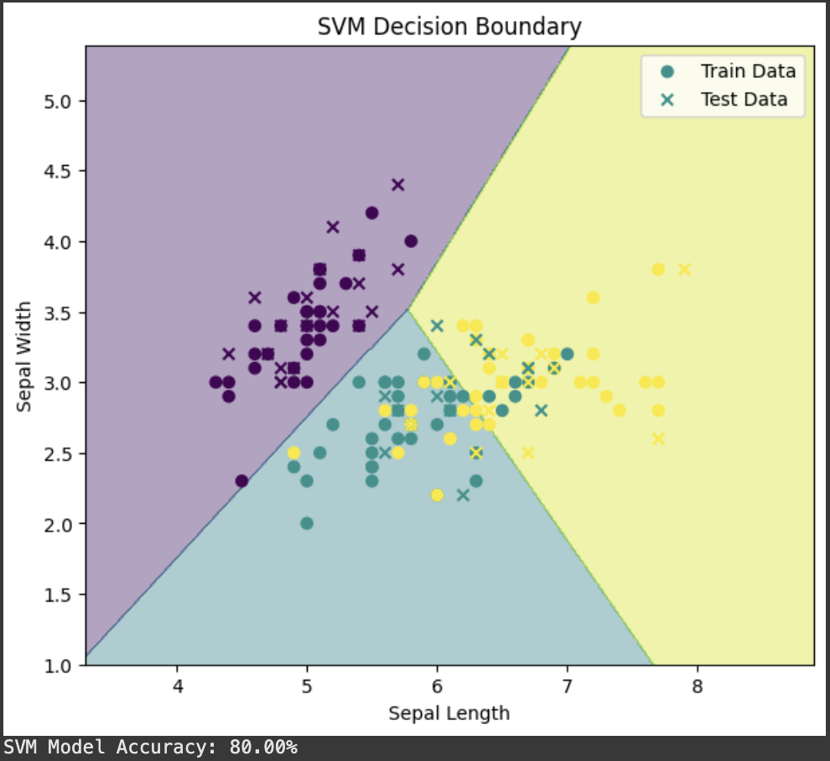

##### Program 8

Implement Random forest ensemble method on a given dataset.

**Screenshots**

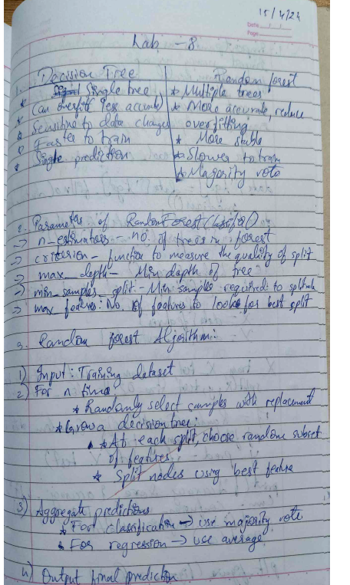

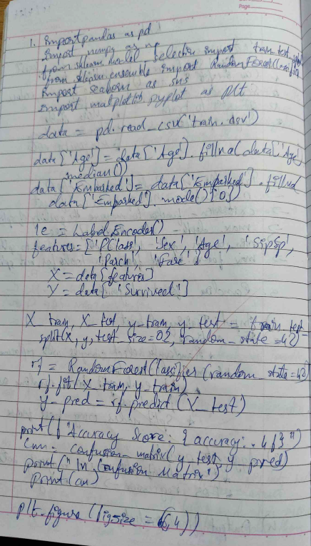

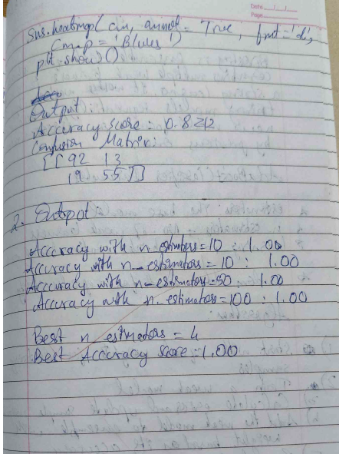

**Code:**

*Using Iris Dataset and visualizing:*

import numpy as np

import matplotlib.pyplot as plt

from sklearn.datasets import load_iris

from sklearn.ensemble import RandomForestClassifier

from sklearn.decomposition import PCA

# Load Iris dataset

iris = load_iris()

X = iris.data

y = iris.target

# Apply PCA for 2D visualization (reduce to 2 components)

pca = PCA(n_components=2)

X_pca = pca.fit_transform(X)

# Initialize Random Forest Classifier

clf = RandomForestClassifier(n_estimators=100, random_state=42)

# Train the model

clf.fit(X_pca, y)

# Create a mesh grid to plot decision boundaries

x_min, x_max = X_pca[:, 0].min() - 1, X_pca[:, 0].max() + 1

y_min, y_max = X_pca[:, 1].min() - 1, X_pca[:, 1].max() + 1

xx, yy = np.meshgrid(np.arange(x_min, x_max, 0.1),

np.arange(y_min, y_max, 0.1))

# Predict on mesh grid

Z = clf.predict(np.c_[xx.ravel(), yy.ravel()])

Z = Z.reshape(xx.shape)

# Plot decision boundaries

plt.contourf(xx, yy, Z, alpha=0.3, cmap='viridis')

plt.scatter(X_pca[:, 0], X_pca[:, 1], c=y, edgecolors='k', cmap='viridis')

plt.title('Random Forest Decision Boundaries on Iris Dataset (PCA-reduced)')

plt.xlabel('Principal Component 1')

plt.ylabel('Principal Component 2')

plt.colorbar()

plt.show()

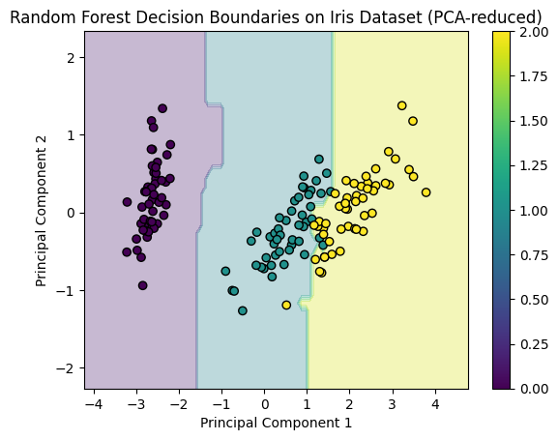

##### Program 9

Implement Boosting ensemble method on a given dataset.

**Screenshots**

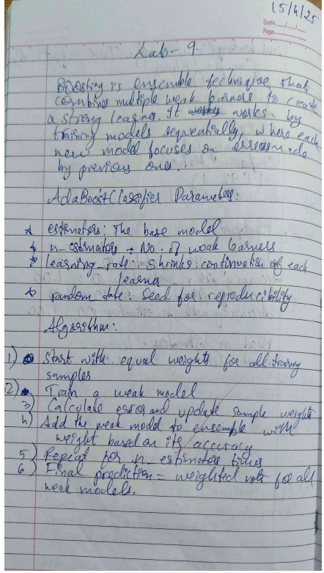

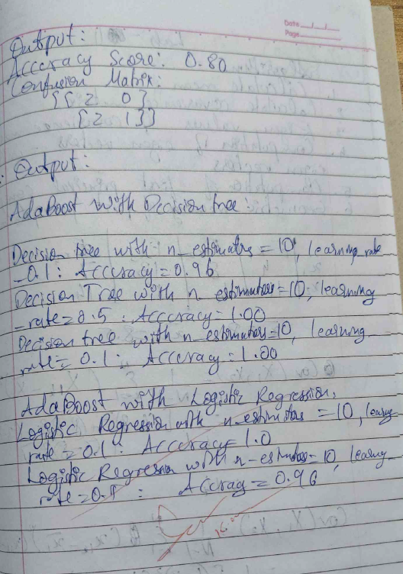

**Code:**

*Using Iris Dataset and visualizing:*

# XGBoost on Iris Dataset with Feature Importance Visualization

import matplotlib.pyplot as plt

import xgboost as xgb

from sklearn.datasets import load_iris

from sklearn.model_selection import train_test_split

# Load Iris dataset

iris = load_iris()

X = iris.data

y = iris.target

# Split dataset into training and testing sets

X_train, X_test, y_train, y_test = train_test_split(X, y, test_size=0.3, random_state=42)

# Initialize XGBoost Classifier

xgb_clf = xgb.XGBClassifier(n_estimators=100, random_state=42)

# Train the model

xgb_clf.fit(X_train, y_train)

# Make predictions

y_pred = xgb_clf.predict(X_test)

# Calculate accuracy

accuracy = (y_pred == y_test).mean()

print(f'XGBoost Classifier Accuracy on Iris Dataset: {accuracy:.4f}')

# Feature importance visualization

xgb.plot_importance(xgb_clf, importance_type='weight', max_num_features=10)

plt.title('Feature Importance for Iris Dataset - XGBoost')

plt.show()

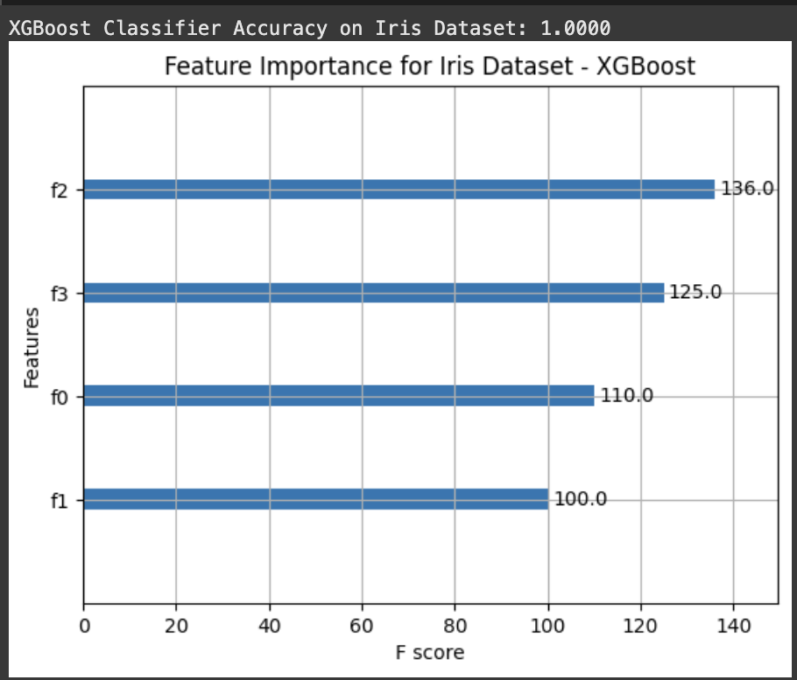

##### Program 10

Build k-Means algorithm to cluster a set of data stored in a .CSV file.

**Screenshots**

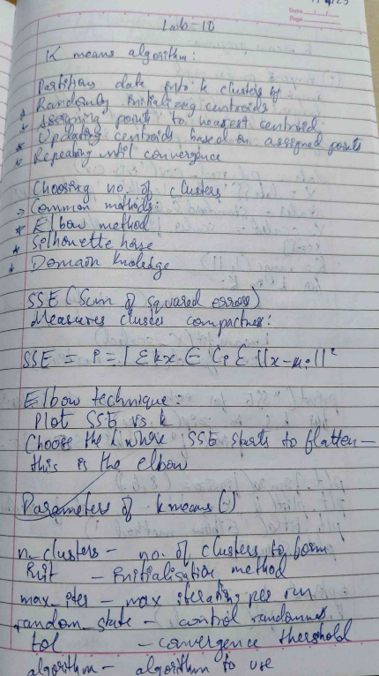

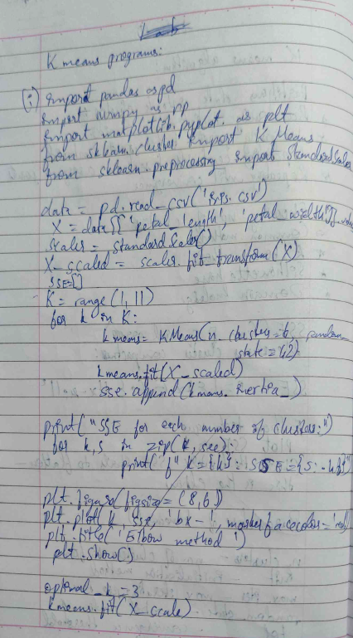

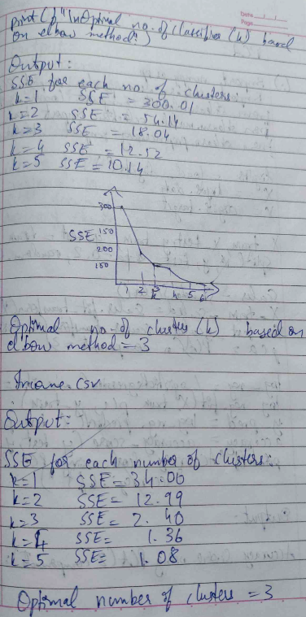

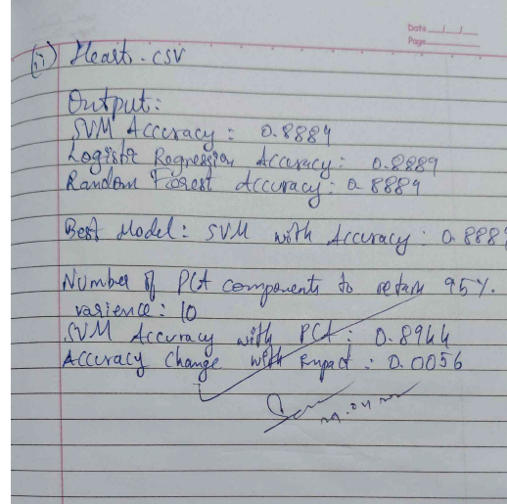

**Code:**

# K-means on Iris Dataset with Visualization

import matplotlib.pyplot as plt

from sklearn.datasets import load_iris

from sklearn.cluster import KMeans

from sklearn.decomposition import PCA

# Load Iris dataset

iris = load_iris()

X = iris.data

y = iris.target

# Apply PCA for 2D visualization (reduce to 2 components)

pca = PCA(n_components=2)

X_pca = pca.fit_transform(X)

# Perform K-means clustering (3 clusters for 3 species in Iris)

kmeans = KMeans(n_clusters=3, random_state=42)

y_kmeans = kmeans.fit_predict(X)

# Visualize the clustering result in 2D (PCA-reduced space)

plt.figure(figsize=(8, 6))

plt.scatter(X_pca[:, 0], X_pca[:, 1], c=y_kmeans, cmap='viridis')

plt.scatter(kmeans.cluster_centers_[:, 0], kmeans.cluster_centers_[:, 1], s=200, c='red', marker='X', label='Centroids')

plt.title('K-means Clustering on Iris Dataset (PCA-reduced)')

plt.xlabel('Principal Component 1')

plt.ylabel('Principal Component 2')

plt.colorbar(label='Cluster')

plt.legend()

plt.show()

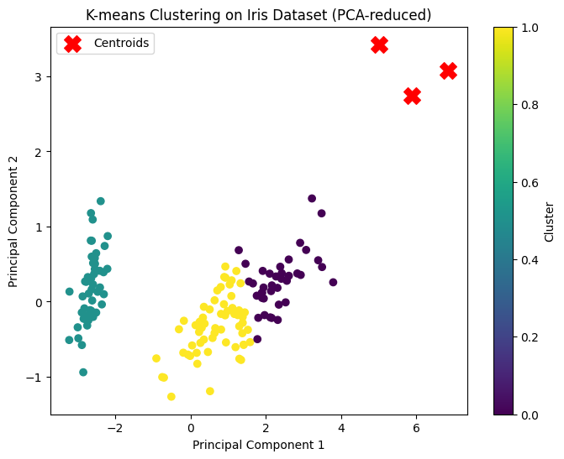

# K-means on Kaggle Titanic Dataset with Visualization

import pandas as pd

import matplotlib.pyplot as plt

from sklearn.cluster import KMeans

from sklearn.decomposition import PCA

# Load Titanic dataset (You can replace the URL with your own Kaggle dataset link)

url = "https://raw.githubusercontent.com/datasciencedojo/datasets/master/titanic.csv"

data = pd.read_csv(url)

# Preprocessing: Selecting relevant features and dropping missing values

data = data.dropna(subset=['Pclass', 'Age', 'Fare'])

X = data[['Pclass', 'Age', 'Fare']]

# Normalize the data (optional, but helps with clustering)

X = (X - X.mean()) / X.std()

# Apply K-means clustering (let's assume we use 3 clusters for this example)

kmeans = KMeans(n_clusters=3, random_state=42)

y_kmeans = kmeans.fit_predict(X)

# Apply PCA for 2D visualization (reduce to 2 components)

pca = PCA(n_components=2)

X_pca = pca.fit_transform(X)

# Plot the clusters in 2D

plt.figure(figsize=(8, 6))

plt.scatter(X_pca[:, 0], X_pca[:, 1], c=y_kmeans, cmap='viridis')

plt.scatter(kmeans.cluster_centers_[:, 0], kmeans.cluster_centers_[:, 1], s=200, c='red', marker='X', label='Centroids')

plt.title('K-means Clustering on Titanic Dataset (PCA-reduced)')

plt.xlabel('Principal Component 1')

plt.ylabel('Principal Component 2')

plt.colorbar(label='Cluster')

plt.legend()

plt.show()

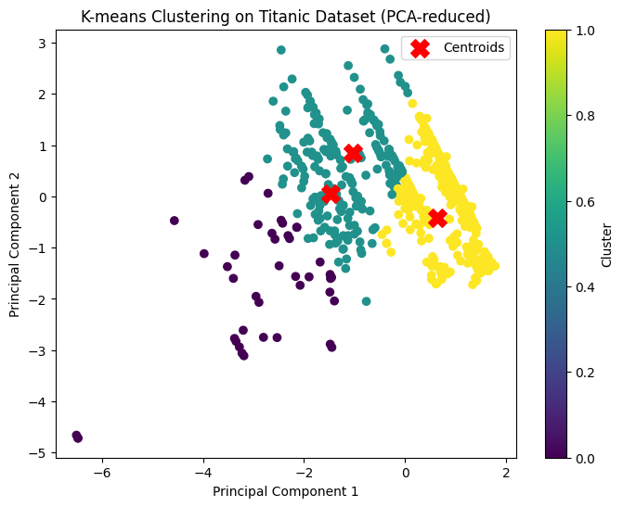

##### Program 11

Implement Dimensionality reduction using Principal Component Analysis (PCA) method.

**Screenshots**

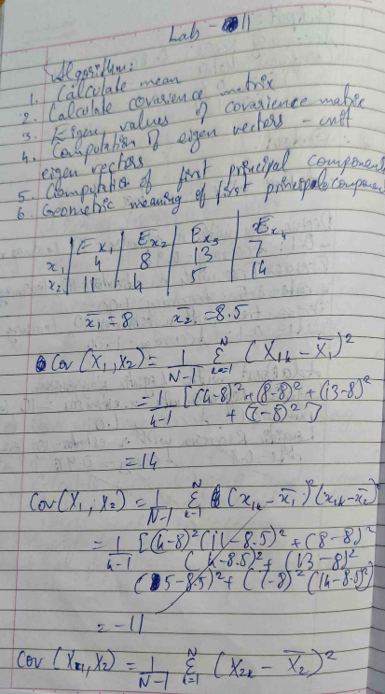

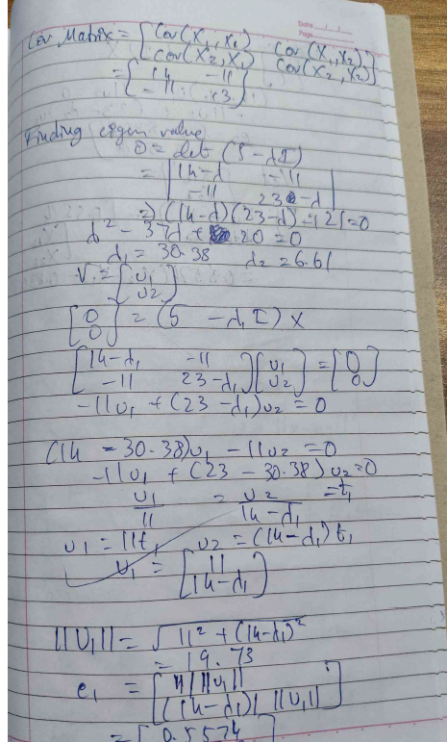

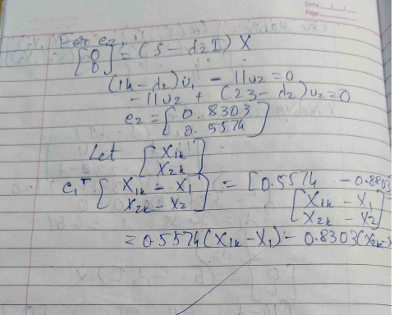

**Code:**

*Using Iris Dataset and visualizing:*

# PCA on Iris Dataset with Visualization

import matplotlib.pyplot as plt

from sklearn.datasets import load_iris

from sklearn.decomposition import PCA

# Load Iris dataset

iris = load_iris()

X = iris.data

y = iris.target

# Apply PCA to reduce data to 2D

pca = PCA(n_components=2)

X_pca = pca.fit_transform(X)

# Plot the PCA-reduced data

plt.figure(figsize=(8, 6))

plt.scatter(X_pca[:, 0], X_pca[:, 1], c=y, cmap='viridis')

plt.title('PCA on Iris Dataset')

plt.xlabel('Principal Component 1')

plt.ylabel('Principal Component 2')

plt.colorbar(label='Target Class')

plt.show()

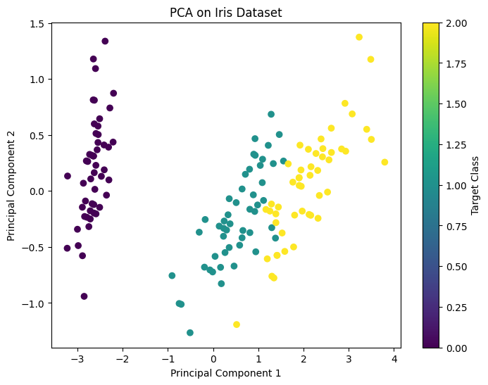

*Using Kaggle Titanic Dataset and visualizing:*

# PCA on Kaggle Titanic Dataset with Visualization

import pandas as pd

import matplotlib.pyplot as plt

from sklearn.decomposition import PCA

from sklearn.preprocessing import LabelEncoder

# Load Titanic dataset (Replace with your dataset URL or local file path)

url = "https://raw.githubusercontent.com/datasciencedojo/datasets/master/titanic.csv"

data = pd.read_csv(url)

# Preprocess the dataset: Handle missing values and encode categorical features

data = data.dropna(subset=['Pclass', 'Age', 'Fare'])

data['Sex'] = LabelEncoder().fit_transform(data['Sex'])

# Select relevant features

X = data[['Pclass', 'Age', 'Fare']]

y = data['Survived']

# Apply PCA to reduce data to 2D

pca = PCA(n_components=2)

X_pca = pca.fit_transform(X)

# Plot the PCA-reduced data

plt.figure(figsize=(8, 6))

plt.scatter(X_pca[:, 0], X_pca[:, 1], c=y, cmap='coolwarm')

plt.title('PCA on Titanic Dataset')

plt.xlabel('Principal Component 1')

plt.ylabel('Principal Component 2')

plt.colorbar(label='Survived (0=No, 1=Yes)')

plt.show()

